**UPPER RIO GRANDE WATER OPERATIONS MODEL**

**(URGWOM)**

**Operations Ruleset Documentation**

**VOLUME 2a**

Version 9.3

September 26 2024

*Submitted to:*

U.S. Army Corps of Engineers Albuquerque District

4101 Jefferson Plaza NE Albuquerque, New Mexico 87109

*Prepared by:*

Tetra Tech, Inc. Hydros Consulting

6121 Indian School Road NE, Suite 205 1628 Walnut Street Albuquerque, New Mexico 87110 Boulder, Colorado 80302

**Tetra Tech Inc.: Contract W912PP-19D-0025, Delivery Order No. W912PP20D0034 Hydros Consulting: Contract: W912PP-22-F-0015**

Page Intentionally Left Blank

# Table of Contents

Table of Contents

Table of Contents 3

List of Figures 5

List of Tables 5

Abbreviations and Acronyms Used 6

1 Introduction 7

2 Forecast Error and Rio Grande Compact Rules 12

2.1 The Rio Grande Compact 12

2.1.1 Article VII of the Rio Grande Compact & Relinquished Credits 13

3 Colorado Rules 14

3.1 Introduction to Colorado Rules 15

3.2 Colorado Policy Controls 16

3.2.1 Rio Grande Compact 16

3.2.2 Water Rights 17

3.2.3 Reservoir Operations 18

3.3 Colorado Reservoir Specific Operations 18

3.3.1 Platoro Dam 18

4 Middle Rio Grande Rules 23

4.1 Introduction to MRG Rules 23

4.2 MRG Policy Controls 25

4.2.1 San Juan-Chama Project 25

4.2.2 Flood Control Operations 29

4.2.3 Rio Grande Compact 30

4.2.4 Diversions 31

4.2.5 Downstream Target Flows 34

4.2.6 Recreation 38

4.3 MRG Reservoir Operations 39

4.3.1 Heron Dam 39

4.3.2 El Vado Dam 40

4.3.3 Abiquiu Dam 41

4.3.4 Cochiti and Jemez Canyon Dams 42

5 Lower Rio Grande Rules 44

5.1 Introduction to LRG Rules 45

5.2 LRG Policy Controls 46

5.2.1 Rio Grande Project Allocations 46

1.1.1 Pattern-Based Operations 47

5.2.2 Demand-Based Operations 50

5.2.3 Reservoir Operations 52

References 53

APPENDIX A: Flowchart for Input Data & Rio Grande Compact ..................................................... A-1 APPENDIX B: Flowchart for Colorado Policy.....................................................................................B-1

APPENDIX C: Flowchart for MRG Policy ..........................................................................................C-1

APPENDIX D: Flowchart for Lower Rio Grande Policy .................................................................... D-1

APPENDIX E: Forecast Error & Rio Grande Compact Rules..............................................................E-1 APPENDIX F: Individual Colorado Rules............................................................................................ F-1

APPENDIX G: Individual Middle Rio Grande Rules.......................................................................... G-1

APPENDIX H: Individual Lower Rio Grande Rules ........................................................................... H-1

# List of Figures

Figure 1: Upper Rio Grande Basin 9

Figure 2: Policy Groups and associated rule priorities in the URGWOM 7.4 Operations Ruleset 11

Figure 3: Rio Grande Watershed in Colorado 14

Figure 4: Example portion of URGWOM in Colorado 14

Figure 5: Colorado Operations Ruleset Policy Groups 16

Figure 6: Platoro Flood Control Storage Reservation Diagram 19

Figure 7: Middle Rio Grande Operations Ruleset Policy Groups 24

Figure 8: The San Juan – Chama project diversion and tunnel locations and capacities 25

Figure 9: The Little Navajo River (left) and Navajo River (right) downstream of the Little Oso and Oso diversion dams respectively (courtesy of Reclamation) 26

Figure 10: El Vado Dam (courtesy of Reclamation) 29

Figure 11: Five Low Flow Conveyance Channel pumps ready to pump to the river 38

Figure 12: Heron Dam & Reservoir (courtesy of Reclamation) 40

Figure 13: El Vado Dam and Outlet Works 40

Figure 14: Abiquiu Dam and Outlet Works 41

Figure 15: Map of Lower Rio Grande area 44

Figure 16: Example portion of URGWOM in LRG 45

Figure 17: Lower Rio Grande Operations ruleset Policy Groups 46

Figure 18: Water Accounts for the Rio Grande Project on the Caballo Reservoir Object. 47

Figure 19: Annual distribution of allocation to river headings for EBID, EPCWID, and Mexico. 48

Figure 20: Daily distribution of diversion requests for Leasburg and Picacho diversion 49

Figure 21: Thresholds for WetDryAvg index 49

Figure 22: Daily distribution of releases from Caballo reservoir 51

Figure 23: Elephant Butte dam (courtesy of Reclamation) 52

# List of Tables

Table 1: Minimum Bypass Flows at the San Juan Basin Diversions (cfs) 26

Table 2: San Juan Chama Project Water Allocations in URGWOM (cfs) 27

# Abbreviations and Acronyms Used

AOP Annual Operating Plans

BIA Bureau of Indian Affairs

CADSWES Center for Advanced Decision Support for Water and Environmental Systems CDWR Colorado Department of Water Resources

Compact Rio Grande Compact

EBID Elephant Butte Irrigation District

EPCWID El Paso County Water Improvement District No. 1 ESA Endangered Species Act

LRG Lower Rio Grande

MRG Middle Rio Grande

MRGCD Middle Rio Grande Conservancy District

P&P Prior and Paramount

Project Rio Grande Project

Pueblos Six Middle Rio Grande Pueblos

RPL RiverWare Policy Language

# Introduction

URGWOM (The Upper Rio Grande Water Operations Model) was developed with the RiverWare software application developed at the Center for Advanced Decision Support for Water and Environmental Systems (CADSWES) at the University of Colorado at Boulder. The model is a daily or monthly timestep model for simulating operations of facilities and diversions along the Rio Grande and major tributaries within Colorado, New Mexico, Texas, and Mexico. Reservoir operations are simulated at Platoro, Heron, El Vado, Abiquiu, Nambe, Cochiti, Jemez Canyon, Elephant Butte, and Caballo Dams. Diversions at numerous locations along the Conejos River, Rio Los Pinos, Rio San Antonio, Rio Chama, and Rio Grande are simulated along with drain and canal flows in the Middle and Lower Rio Grande Valleys. Refer to Figure 1 for a map of the Rio Grande basin upstream of Fort Quitman TX.

A single URGWOM model file is maintained and used for multiple applications including model runs for long-term planning studies, simulations with forecasted inflows for preparing Annual Operating Plans (AOP), and daily after the fact simulations for accounting purposes. The URGWOM Operations ruleset (ruleset) described in this document is used for all daily or monthly timestep rulebased simulations including model runs for planning studies and to prepare AOPs and other short-term forecasts of operations. Modeling for planning studies is used to evaluate potential long-term impacts of a proposed action on various indicators including deliveries to water users, river flows, interstate Compact deliveries and Compact status, and the overall water budget. AOP modeling and other short- term forecasts are completed as rulebased simulations to forecast operations, deliveries, and resulting flows through the end of a calendar year with forecasted inflows computed with forecast calculations.

The Accounting Model application is used to complete model runs, without rules, up to the current date using actual data to simulate the status of accounts for different water users.

The Upper Rio Grande system is made up of three largely separate operational units or model portions: Colorado, New Mexico upstream of Elephant Butte, and New Mexico and Texas from Elephant Butte downstream to Fort Quitman. For the purposes of this discussion these will be referred to as the Colorado, Middle Rio Grande (MRG), and Lower Rio Grande (LRG) portions respectively. Operations in these portions can impact the other portions through hydrologic connectivity and legal agreement; flows from Colorado move downstream to the MRG and flows from the MRG move downstream to the LRG, while reservoir levels in Elephant Butte can impact reservoir operations upstream in Colorado and the MRG through Article VII of the Rio Grande Compact (Compact). So, while the operations in each portion may impact operational decisions of the other two, these three portions each make operational decisions that are largely independent of operations in the other two portions. This report describes river operations in the Rio Grande system in Colorado, the MRG, and the LRG as implemented by the URGWOM Operations ruleset. The URGWOM Operations ruleset is organized based on these portions, with an additional group of rules associated with data input and Compact accounting that are relevant to operations throughout the basin. Following the URGWOM Operations ruleset, this documentation is organized into four main sections corresponding to Forecast Error (for Planning Studies) and Compact rules, Colorado rules, MRG rules, and LRG rules. This document serves as a reference for URGWOM users

working with the RiverWare Policy Language (RPL) developed Operations ruleset and provides a means to review the policy as coded in the model. The version number for this document matches the version number for the corresponding Operations ruleset file.

URGWOM has been under development for many years and changes are always being made to enhance the model and improve the reliability of the results. This report focuses solely on the ruleset portion of the model which contains code for completing rulebased simulations. The ruleset includes a series of rules coded in the RPL. The series of rules represents the policy for operating the facilities throughout the basin and ultimately setting the outflows from each modeled dam.

This volume of the documentation describes the Operations ruleset of the URGWOM model. Other URGWOM Documentation volumes cover such topics as Accounting Concepts and Methods, Physical Processes, Initialization ruleset, and other features developed to setup and run the model. The URGWOM Documentation volumes are listed below:

Volume 1: Physical Documentation Volume 2a: Policy Rules Documentation

Volume 2b: Initialization Rules Documentation Volume 2c: Expression Slot Functions Documentation Volume 3: Accounting Concepts and Methods Volume 4: Database Documentation

Volume 5: DMI and SCT Documentation

Volume 6: User's Manual (Script Documentation)

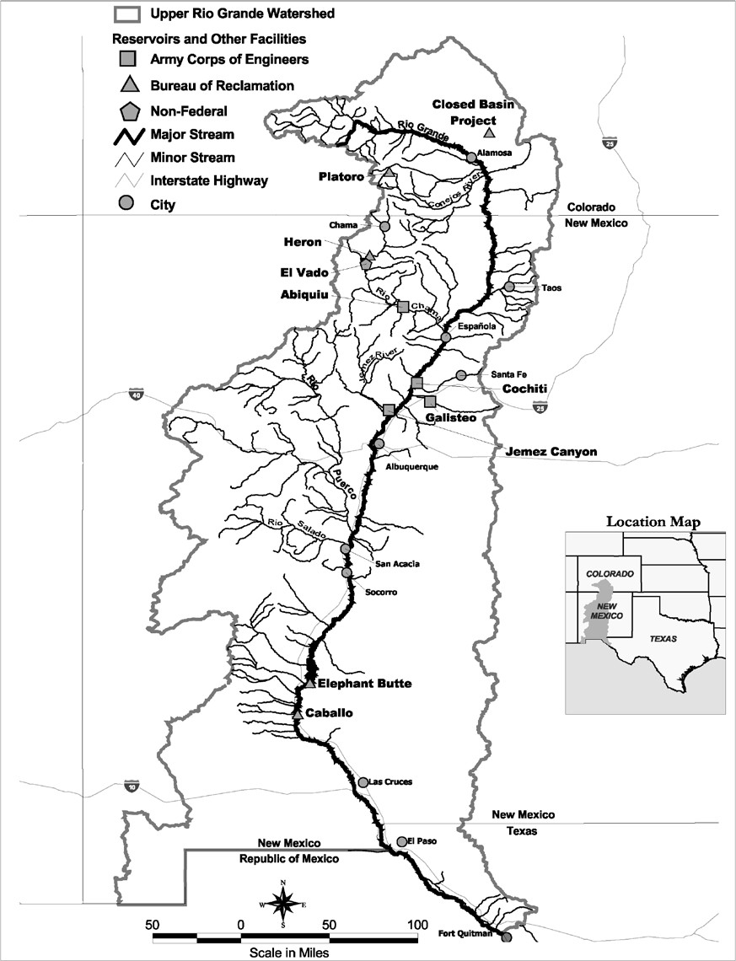

**Figure 1: Upper Rio Grande Basin**

For URGWOM version 9.3, there are 307 rules in 42 policy groups (Figure 2). Assignments for the different parameters completed with each rule are based on the priority for the rule. For example, setting an outflow based on flood control policy will have a higher priority than a delivery to water users. The rules are listed based on priority and are executed, or fired, in reverse order, with rule number 307 firing first in each timestep and rule number 1 firing last. The rules are ordered to set outflows from the dams from upstream to downstream. These rules represent basin policy for such objectives as setting diversions, recording water transfers, meeting downstream target flows, and adhering to flood control operations criteria, all of which ultimately determine the outflow from each modeled dam in the basin. Rules within the URGWOM Operations ruleset are color coded to differentiate different purposes as is explained in more detail in relevant sections of this document. (Rules can also be turned off in which case they do not execute and, if turned off, are noted with a red X in the Operations ruleset. Rules in the ForecastErrors policy group are off by default as seen in Figure 2.) Many values set by the rules can be manually input by the model user to, in effect, override the value that would be set by the rule(s). This allows the user to set values based on the knowledge of the user on current or alternative operations.

Refer to the RiverWare documentation for more details on rulebased simulations.

This report includes three different layers of complexity. The high-level explanation of the overall policy drivers in the three portions of the model is included in the main body of this report. Appendices A through D present logic flowcharts that summarize the overall flow of logic in the ruleset, and list which rules are associated with this logic. These flowcharts are not meant to represent exact implementation of the policy in RPL, but rather the location of RPL rules within a general logic framework that can be understood without any knowledge of RPL. Appendices E through H are very detailed descriptions of the ruleset, are generated by the ruleset itself, and require familiarity with RPL. Information in these final appendices is similar to the information available to a model user with a RiverWare license looking at the actual URGWOM Operations ruleset.

**Figure 2: Policy Groups and associated rule priorities in the URGWOM 9.3 Operations Ruleset**

# Forecast Error and Rio Grande Compact Rules

The URGWOM_9.3 Operations ruleset includes three rules that can be used to add error to forecasts (to incorporate future inflow uncertainty as is faced by actual water operators in the basin), and thirteen rules related to the Rio Grande Compact. The Forecast Error related rules currently only add error to MRG forecasts but could be expanded to include Colorado forecasts (the only inflows to the LRG portion of URGWOM are from the MRG). For this reason, these rules are set to execute before the Colorado or MRG rules. The Compact related rules are needed for operations throughout the basin, and are executed at each timestep prior to the Colorado, MRG, or LRG rules. An overview of the Compact is included in the next Section (2.1), while Compact implications on specific Colorado and MRG operations are discussed in Sections 3.2.1 and 4.2.3 respectively.

For a flowchart of Forecast Error and Rio Grande Compact rules logic, see Appendix A. For RPL code specific implementation of this logic, see Appendix E.

## The Rio Grande Compact

The Rio Grande Compact (New Mexico, Colorado, & Texas, 1938) is a formal agreement between Colorado, New Mexico, and Texas that defines rules for sharing of the water of the Rio Grande.

Delivery requirements from Colorado to New Mexico are set as a portion of the naturalized flow past gages on the Rio Grande, Conejos, San Antonio, and Los Pinos rivers upstream of the major diversions from these systems in Colorado. Actual deliveries are measured at the Lobatos gage near the Colorado New Mexico border. Delivery requirements from New Mexico to Texas are based on naturalized flow past the Otowi gage downstream of the Rio Grande and Rio Chama confluence, and actual deliveries are measured in Elephant Butte Reservoir. Colorado deliveries to New Mexico and New Mexico deliveries to Texas in excess of obligations are stored as wet water in Elephant Butte and cannot be used below Elephant Butte, unless those credits are relinquished to Lower Rio Grande users as described in Section

* + 1. below. Through delivery obligations, Article VII restrictions (defined in Section 2.1.1 below), and water accounting in Elephant Butte, the Compact impacts operations throughout the basin. Colorado diversion operations are driven by curtailments imposed to meet Compact obligations at Lobatos, and reservoir operations at Platoro are impacted by Article VII restrictions. New Mexico diversions from the Rio Grande and tributaries in URGWOM are not currently impacted by New Mexico’s Compact delivery obligations, but El Vado reservoir operations are impacted by Article VII restrictions. The amount of water stored in Elephant Butte that can actually be used for LRG operations depends on Compact accounting. The Compact calculations specific to Colorado and New Mexico delivery obligations and delivery tracking, and Article VII compliance are discussed in Sections 3.2.1 and 4.2.3. Calculation of Article VII conditions, which impact both Colorado and New Mexico operations is discussed in Section 2.1.1 below.

### 2.1.1 Article VII of the Rio Grande Compact & Relinquished Credits

When storage in Elephant Butte and Caballo Reservoirs that can be used in the LRG (not Colorado or New Mexico credit water or San Juan – Chama water) goes below 400,000 acre-feet, so called “Article VII” restrictions go into effect. Under Article VII of the Compact (New Mexico et al., 1938), it is stipulated that native Rio Grande water cannot be stored in post-1929 reservoirs when these restrictions are in place. The “usable storage” is computed with the ComputeUsableStorage rule and includes the total storage at Elephant Butte Reservoir and Caballo Reservoir minus credit water stored at Elephant Butte Reservoir, and any San Juan-Chama Project water. The usable storage is also updated for any relinquished Compact credits as discussed in the next section. For each timestep in the model, a switch is set with the SetCompactArticleVIISwitch rule to identify whether the stipulations of Article VII of the Compact are in effect for that timestep. That switch is then referenced throughout the ruleset. Article VII status affects storage of water in Platoro Reservoir and storage of native Rio Grande water at El Vado Reservoir.

Agreements have been made historically in which Colorado and/or New Mexico Compact credits are relinquished by those states, and water in Elephant Butte that was credit water becomes usable to the LRG. As a result of this accounting transfer in Elephant Butte, an equal amount of water can be stored in Platoro Reservoir (for relinquished Colorado credit water) or El Vado Reservoir or other post-1929 Reservoir (for relinquished New Mexico credit water) at some future date during Article VII conditions as if those conditions were not in effect. Policy is coded to simulate relinquished Compact credits and the subsequent potential for storage and operations for relinquished credits during Article VII conditions.

# Colorado Rules

The Colorado portion of the Upper Rio Grande Basin is characterized by limited storage and large diversions for agricultural use. In Colorado, URGWOM simulates flows along, diversions from, and returns to the Rio Grande downstream of the Thirty Mile Bridge gage, the Conejos River downstream of Platoro Reservoir, and the Rio Los Pinos and Rio San Antonio downstream of gages at Ortiz, Colorado. See Figure 3 and Figure 4.

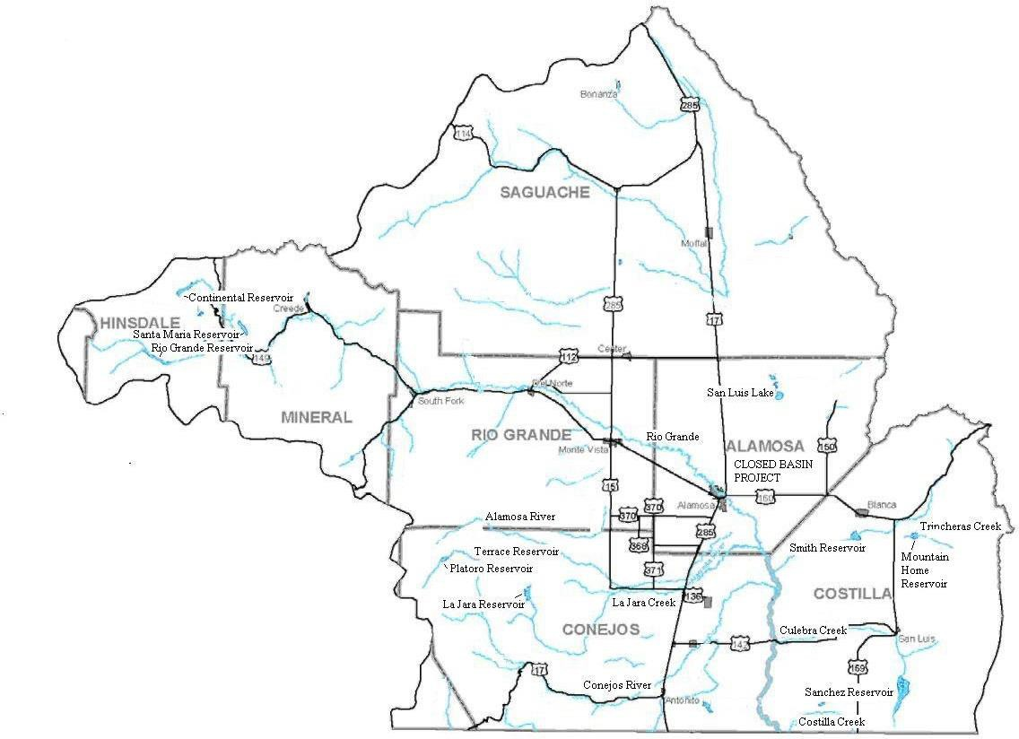

**Figure 3: Rio Grande Watershed in Colorado**

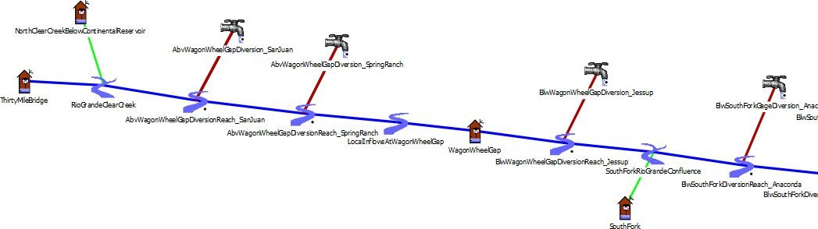

**Figure 4: Example portion of URGWOM in Colorado**

## Introduction to Colorado Rules

Within the URGWOM_9.3 Operations ruleset, there are 47 rules which determine Colorado operations, and these rules are sorted into five different policy groups (See Figure 5). Rules colored red are associated with flood control, green with agricultural operations, aqua with municipal operations, blue with stream flows, orange with Compact operations, magenta with ownership accounting, and purple with reservoir constraints. Assignments for the different parameters are completed with each rule based on the priority for the rule. The rules are listed based on priority and are executed, or fired, in reverse order. For example, Platoro Conservation Storage Policy rules at priority 280-288 fire before the higher priority Platoro Flood Control Policy Group at priority 262-279. Thus, a release set based on conservation storage can be reset by a higher priority flood control rule.

Colorado diversion operations are driven by a combination of Compact delivery obligations to limit water diverted in Colorado, and strict Priority of Appropriation to determine where the diversions within Colorado occur. As seen in Figure 5, rules 288 through 254 in the three policy groups “Platoro Conservation Storage Policy”, “Platoro Flood Control Policy”, and “Platoro Storage Accounting” simulate Platoro Reservoir operations. Rules 253 through 245 in the “Set Colorado Diversions” policy group set Compact curtailment, which is the amount of “Compact” water at each timestep that cannot be diverted from the river. The remaining “allocatable” supply of water is distributed according to water right priority dates using the built in RiverWare function SolveWaterRightsWithLags to set Conejos and Rio Grande diversions. For a flowchart of Colorado rules logic, including Platoro operations, see Appendix B. For RPL code specific implementation of URGWOM policy including the Colorado specific rules, see Appendix F.

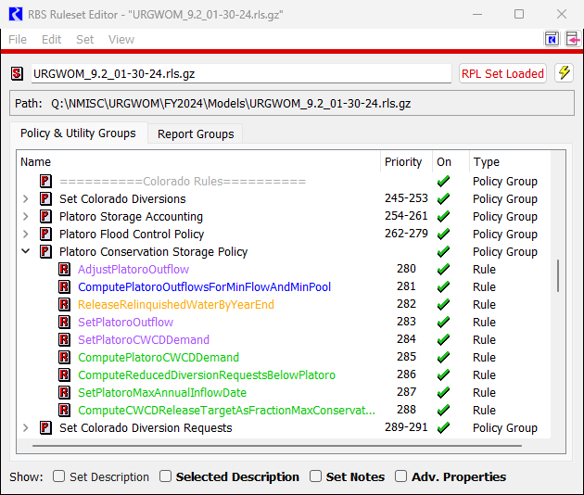

**Figure 5: Colorado Operations Ruleset Policy Groups**

## Colorado Policy Controls

Colorado operations in URGWOM are driven by Compact constraints, Water Rights based allocations, and reservoir operations. These three policy drivers are each described in more detail in the following subsections.

### Rio Grande Compact

The Rio Grande Compact stipulates that the state of Colorado is obligated to deliver water to the Colorado-New Mexico State-line as gaged at the Lobatos gage based on separate delivery requirements from the Conejos River and the Rio Grande. The delivery obligation for the Conejos River is computed as a function of the Conejos Index Supply, which is defined as the natural flow of the Conejos River gaged near Mogote for the calendar year plus the gaged flows in the Los Pinos River near Ortiz and the San Antonio River at Ortiz from April through October. The actual Conejos River delivery to the Rio Grande is the combined discharge of the North and South branches of the Conejos River measured at the

gaging stations near La Sauses over the calendar year. These Conejos gages are included in URGWOM for the Colorado portion of the Rio Grande with the two gages near La Sauses combined into a single gage in the URGWOM representation. The delivery obligation for the Rio Grande is computed as a function of the Rio Grande flow at Del Norte corrected for the operation of reservoirs constructed after 1937. The Rio Grande delivery is calculated as the gaged river flow at Lobatos minus the contribution from the Conejos River as measured at the gages near La Sauses (States of Colorado, New Mexico, and Texas, 1939).

URGWOM Compact curtailments in Colorado are controlled by two slots in the data object CompactCalculations called ConejosCompactCurtailmentPercentage and RioGrandeCompactCurtailmentPercentage. These parameters are calculated within the data object at each timestep and are used by the ruleset to control the portion of allocatable inflows that are curtailed or reserved for delivery to Lobatos. The theoretical curtailment percentage is derived as

𝐶 = 𝐷𝑅𝐶𝐷 = 𝐴𝐷𝑇−𝐷𝑢𝑎𝑖𝑠−𝐷𝑁𝐷−𝐷𝑦𝑡𝑑−𝐷𝑟𝑓 = 𝐷𝑎𝑜+𝐷𝑃𝑝𝑦𝑒−𝐷𝑢𝑎𝑖𝑠−𝐷𝑁𝐷−𝐷𝑦𝑡𝑑−𝐷𝑟𝑓

(1)

𝑀𝑅𝐴𝐷

𝑀𝑅𝐴𝐷

𝑀𝑅𝐴𝐷

Where *C* is curtailment percentage, *DRCD* is desired remaining compact deliveries of allocatable water *during irrigation season*, and *MRAD* is the maximum remaining allocatable deliveries *during irrigation season*. In other words, the curtailment is the ratio of allocatable deliveries needed to the maximum allocatable deliveries. *DRCD* is equal to the annual delivery target (*ADT*) minus remaining unallocatable irrigation season deliveries (𝐷𝑢𝑎𝑖𝑠) minus November and December deliveries (𝐷𝑁𝐷) minus the year to date delivery (𝐷𝑦𝑡𝑑) minus deliveries associated with return flows of allocated water (𝐷𝑟𝑓). The ADT is calculated as the annual delivery obligation (𝐷𝑎𝑜) plus the departure (negative balance) at the previous year end (𝐷𝑃𝑝𝑦𝑒) . In the case of the Conejos, the implementation of Equation 1 in RPL does not include return flows of allocated water (𝐷𝑟𝑓) because calibration results in the Conejos were (unlike in the Rio Grande) acceptable without this term.

In 1981, the Rio Grande Water Users Association and Conejos Water Conservancy District agreed to assign 60,000 acre-ft of annual and accrued debit to the Rio Grande and 40,000 acre-ft to the Conejos River. That agreement was a onetime operational decision, but based on those operations, a 60%/40% ratio is used in URGWOM as a model default to split a 10,000 acre-ft annual Compact delivery credit to Colorado, and to split the credit for inflows to the system from the Closed Basin Project. In URGWOM, the contribution from the South Channel Norton Drain counts toward the delivery requirement for the Conejos River. (The North Channel Norton Drain discharges to the Rio Grande upstream of the Rio Grande at La Sauses gage.)

### Water Rights

Water rights in Colorado are adjudicated based upon the doctrine of prior appropriation, where users who started diverting water at an earlier date have priority over users who started diverting water later. Depending upon Compact curtailments and the total flow in the river, a certain number of water users will have priority and be able to divert water in a given model timestep. The available allocatable flow may be curtailed to assure Compact delivery obligations are met at the State-line. Once the allocatable

flow has been set, water right based diversions are solved with the RiverWare predefined function SolveWaterRightsWithLags. This function requires all the diversion accounts to be in a computational subbasin. All water users in the Colorado portion of URGWOM are grouped into either the Rio Grande (District 20 of Colorado Water Division 3) or Conejos River (District 22) computational subbasins.

Water accounting is used to track the allocatable flow in the river that is available for diversion separate from the portion of flow that may be specifically designated for Compact delivery, set as a function of a computed Compact curtailment. Separate diversion accounts are used to track diversions that are in priority by water right date. Physical diversions are computed as a sum of all the resulting diversions by water right that are associated with each physical diversion. As explained in more detail in the URGWOM Physical Model documentation, return flows in Colorado are set as a constant fractional return depending on the diversion location. The Water Accounting setup and methods used in URGWOM are described in more detail in Volume 3 of the URGWOM documentation.

### Reservoir Operations

Platoro Reservoir is the only Colorado reservoir simulated in URGWOM and is operated for both flood control and conservation storage purposes as described in more detail in Section 3.3.1 below. Rio Grande and Continental reservoirs are not within the current URGWOM model extent, and Santa Maria Reservoir, which provides off channel storage in the reach upstream of Wagon Wheel Gap, is within the model extent, but is not modeled. In 2014, members of the URGWOM Tech Team visited Rio Grande, Continental, and Santa Maria Reservoirs and discussed addition of these reservoirs to the Colorado Portion of URGWOM. It was determined at that time that addition of these small reservoirs to the model would be deferred for reconsideration at a future date.

## Colorado Reservoir Specific Operations

### Platoro Dam

The policy guiding Platoro operations is summarized here. For a flowchart of Colorado rules logic, including Platoro operations, see Appendix A. For RPL code specific implementation of URGWOM policy including the Colorado specific rules, see Appendix E.

#### Platoro Flood Control

Flood control operations at Platoro are in effect throughout the months of March through July of each year based on the USACE January 1963 Flood-Control Storage Reservation Diagram (Diagram) shown in Figure 6 (USACE, 1963) and a spreadsheet called FLODSP7A.xlsx was developed to help automate the use of the Diagram. The flood control diagram specifies an evacuation period from March 1 through May 9, and a filling period from May 10 through July 31. Curves for the evacuation period use forecasted and historical runoff volumes to reach a target storage on May 10, after which time Platoro can fill depending on the remaining forecasted runoff through July.

**URGWOM RULES Version 9.3**



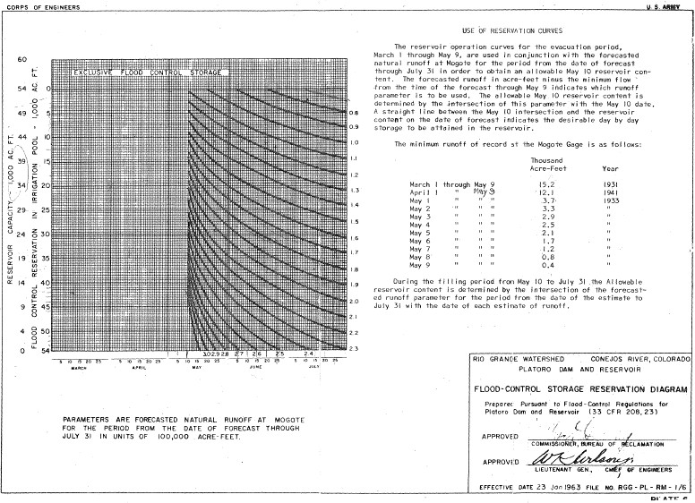

**Figure 6: Platoro Flood Control Storage Reservation Diagram**

The current spreadsheet implementation is documented in a 1995 technical memorandum authored by Hydrosphere (Udall, 1995), and a 2012 list of updates (Sidlow, 2012). Flood control operations at Platoro as implemented in URGWOM follow this methodology and are shown on page A-3 of APPENDIX A.

#### Platoro Conservation Storage

Water storage for reasons not related to flood control is referred to here as conservation storage. Conservation storage occurs in Platoro under three different policy mechanisms, 1) Decree Storage, 2) Compact Storage, and 3) Direct Flow Storage.

* + - * 1. Platoro Decree Storage

Decree Storage is water that can be stored in Platoro based on a junior water right when all more senior water rights are satisfied. The most junior diversion right currently tracked on the Conejos in the Colorado portion of URGWOM has a 1910 priority date. Platoro was built between 1949 and 1951 and has a storage right junior to all diversion rights in the model. As a result of this junior status, Decree Storage typically occurs in the winter when there is no diversion demand and during large inflows when all diversion demands that could be served by inflow to Platoro are satisfied. Winter storage is constrained by a minimum environmental release requirement of 7 cfs. As long as it was not stored during Article VII restrictions this water can be carried over from year to year and released by the Conejos Water Conservancy District when and as needed (Cotten, 2017b).

Conceptually Decree Storage during irrigation season could have been implemented in either of two ways, 1) by using the RiverWare water rights solver to solve for Platoro storage as part of the allocatable supply chain, or 2) by estimating the total water rights demand on the Conejos downstream of Platoro and leaving the basic structure of accounting unchanged. The second option was selected. The logic utilized is summarized as follows where ≡ means “is defined as”:

Water rights on Conejos above Mogote ≡ a

Water rights on Conejos from Mogote to San Antonio confluence ≡ b

Water rights on Conejos from San Antonio confluence down ≡ c

Water rights on San Antonio above San Antonio confluence ≡ d.

Platoro inflows ≡ w

Mogote local inflows ≡ x

Los Pinos & San Antonio inflows at Ortiz ≡ y

San Antonio local inflows ≡ z

Return flow % ≡ r%

Then San Antonio Surplus = max(0, y – d) + min(y,d)*r% + z ≡ SAS

Upper Conejos Delivery = a ≡ UCD

Mid Conejos Delivery = max(0, b – (x + a*r%)) ≡ MCD

Lower Conejos Delivery = c – (b*r% + SAS) ≡ LCD

Platoro Decree Storage = w – (UCD + MCD + LCD)

Initial implementation of this approach resulted in less storage in the Platoro historical run between 1988 and 2011 than was observed, and so a calibration factor of 70% was added to reduce the term (UCD + MCD + LCD). Using this methodology, URGWOM Decree Storage added in Platoro as a function of system inflows compared well with historical observations for the 1993-2001 period, which was used as a representative period of conservation storage operations.

Decree Water releases in a given year are determined based on an empirical linear relationship between annual Platoro inflows and the percentage of maxjmum storage released between peak storage and November 1st, developed by analysis of historical operations from 1993 through 2001. For Platoro inflows of 40,000 AF (dry), the model targets a release of 56% of peak storage, and for inflows of 100,000 AF (wet), targets a release of 20% of peak storage.

* + - * 1. Platoro Compact Storage

Compact Storage Water is a fairly small amount of water that may be stored in Platoro in case it is needed later in the season to meet Compact delivery obligations for the Conejos (Cotten, 2017a). With perfect information on system inflows throughout a given year, URGWOM accurately curtails irrigation diversions in the Conejos to ensure sufficient compact deliveries without reserved storage to hedge against the hydrologic uncertainty that characterizes actual operations. As a result of the difference between modeled and actual operations, and the small amount of water stored, Platoro Compact Storage is not currently included URGWOM.

* + - * 1. Platoro Direct Flow Storage

Direct Flow Storage occurs when a ditch on the Conejos system decides to store water in Platoro that it would otherwise be in priority to divert at the headgate and releases that water for diversion later in the same irrigation season. According to Craig Cotten of the Colorado Department of Water Resources (CWDR) this type of storage addition is generally limited to a period starting after peak inflow and lasting for a month or so (Cotten, 2017a). As described by Craig Cotten (2015):

*“It is a joint decision by the water rights holders and my office as to when and how much of this type of water can be stored. The water rights holders do acquire a loss both when they store the water and when they release the water. They generally want to store more water and for a longer period of time than I will allow them to. My main concern in whether or not to allow the storage of this water is whether this*

*operation will injure junior water rights holders. For instance, physically running this water into senior ditches results in return flows that can be used in junior ditches, and there are times in which the senior ditch lands would be saturated and no longer need the water for a period of time if they were to keep running the water in the ditches instead of storing it. This would allow junior ditches to come into priority, which may not happen if storage is allowed. So I generally restrict these ditches from storing until we reach the peak of the runoff (which is difficult to determine at the time). This allows all of the ditches that could have been in priority to divert to actually get some water. In addition, the ditches cannot store more water than they can use during the remainder of the irrigation season, they have to pay a nominal fee for the storage, and they get charged losses both at the front and at the back end, so this cuts down on the amount of storage that the owners want to do.”*

This storage is implemented in URGWOM using the data object table PlatoroData.IrrigationDemandReductionTimeParameters and the scalar object PlatoroData.IrrigationDemandReduction with adjustable inputs that determine how many days of full delivery at a ditch would result in some other number of days of reduced delivery. The model default for these parameters means that in April and October, if a Conejos water user has 5 consecutive days of fully served demand, then the next 9 days of demand by that user will be reduced to 80% of normal. In May and September, 6 consecutive days of fully served demand will result in a demand reduction to 80% of normal for the next 8 days, and in June through August, 7 days of fully served demand result in 7 days of demand reduced to 80% of normal. These default parameters are educated guesses informed to a small degree by calibration to historical Platoro storage and could be improved with data on historical direct flow storage operations by ditch.

#### Platoro Operation under Article VII

Article VII of the Compact states that, “Neither Colorado nor New Mexico shall increase the amount of water in storage in reservoirs constructed after 1929 whenever there is less than 400,000 acre feet of usable water in project storage.” With the agreement of Texas, Colorado Compact credit water can be converted to usable water in exchange for “relinquished credits,” which allows storage during Article

VII. The interpretation of Article VII used by CDWR is that storage cannot be increased from one Compact accounting period (calendar year) to the next without using relinquished credits. Again, from Craig Cotten (2015):

*“Also, since Platoro is a post-compact reservoir, we cannot allow Platoro to gain in storage from one calendar year to the next without a specific agreement with Texas to do so. Over the last few years we have had a relinquishment agreement in place that allows us to gain 'long term' storage in Platoro, up to a total of 3,000 acre-feet. We have stored approximately 1,760 acre-feet of that during the previous 2 years, and so we have a remaining approximately 1,240 acre-feet that we*

*can store even while in article 7 restrictions.”*

# Middle Rio Grande Rules

The MRG portion of the Upper Rio Grande Basin is characterized by gaining reaches from Colorado to the Rio Grande at Otowi Bridge gage (Otowi) on the mainstem Rio Grande, native and transbasin inflows and three storage reservoirs in the tributary Rio Chama basin, and substantial agricultural, riparian, and municipal-industrial use from Otowi to Elephant Butte. In the MRG, in addition to the three Chama basin reservoirs, URGWOM simulates operations of one mainstem reservoir (Cochiti) and two smaller tributary reservoirs (Nambe Falls Dam and Jemez Canyon Dam). The majority of MRG rules are associated with operations of the Chama basin reservoirs (Heron, El Vado, and Abiquiu). Diversions at numerous locations along the Rio Chama and Rio Grande are simulated along with drain and canal flows in the Middle Valley between Cochiti Dam and Elephant Butte Reservoir, and operations of these diversions and conveyance flows are also controlled with the URGWOM Operations ruleset. A more detailed description of the physical and hydrologic features of the MRG can be found in Volume 1 (URGWOM Physical Model Documentation).

## Introduction to MRG Rules

Within the URGWOM_9.3 Operations ruleset, there are 165 rules which determine MRG operations, and these rules are sorted into 31 different policy groups (see Figure 7). Rules colored red are associated with flood control, green with agricultural operations, aqua with municipal operations, blue with stream flows, orange with Compact operations, magenta with ownership accounting, and purple with reservoir constraints. Assignments for the different parameters are completed with each rule based on the priority for the rule. The rules are listed based on priority and are executed, or fired, in reverse order. For example, Abiquiu Deliveries rules at priority 129-140 fire before the higher priority Abiquiu Reservoir Operations at priority 122-128. Thus, a release set based on target downstream deliveries can be reset by a higher priority flood control rule.

MRG operations are driven by the trans-basin diversion of water from the San Juan River basin to the Rio Chama basin, accounting for San Juan water and native Rio Grande water, flood control operations, the interstate Compact, diversions by the Middle Rio Grande Conservancy District (MRGCD) and other water users including the six Middle Rio Grande pueblos, releases to meet downstream target flows to comply with the 2003 BO, and operations for recreational interests. Operations are significantly complicated by the separate accounting for imported San Juan-Chama Project water versus native Rio Grande water. Following URGWOM convention, Rio Grande water refers to any water that originates within the basin (including on tributaries to the Rio Grande), while San Juan or San Juan-Chama water is water diverted to the Rio Grande basin from the San Juan basin through the San Juan-Chama Project facilities.

The following sections describe the basin scale and individual reservoir policy controls that together determine MRG operations. For more specific information on how this policy is implemented in URGWOM, a flowchart of URGWOM provided in Appendix C, and detailed RPL code specific information for each rule is provided in Appendix G.

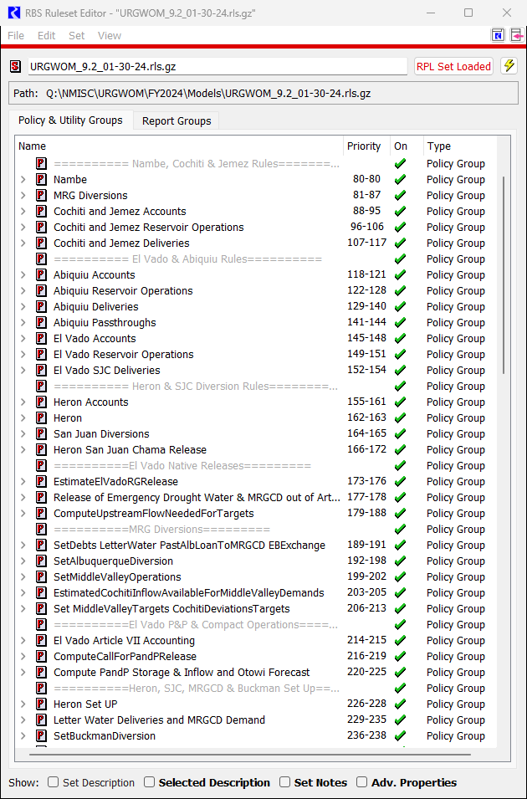

**Figure 7: Middle Rio Grande Operations Ruleset Policy Groups**

## MRG Policy Controls

MRG operations in URGWOM are driven primarily by policy associated with the San Juan – Chama Project, flood control, Compact, diversions, target flows, and recreation operations. These six policy drivers are each described in more detail in the following subsections.

### San Juan-Chama Project

The initial stage of the San Juan-Chama Project was authorized by Congress in 1962 and allows for trans-basin diversion of water from the San Juan River to the Rio Grande basin. The project is part of the Colorado River Storage Project to allow for New Mexico to utilize its 11.25% share of the Colorado River water as stipulated in the Upper Colorado River Basin Compact (New Mexico, Colorado, Utah, Arizona, & Wyoming, 1948). Water from three tributaries to the San Juan River, the Rio Blanco, Little Navajo River, and Navajo River is diverted through tunnels connecting the three tributaries and flows under the Continental Divide into the Rio Chama basin as shown in Figure 8.

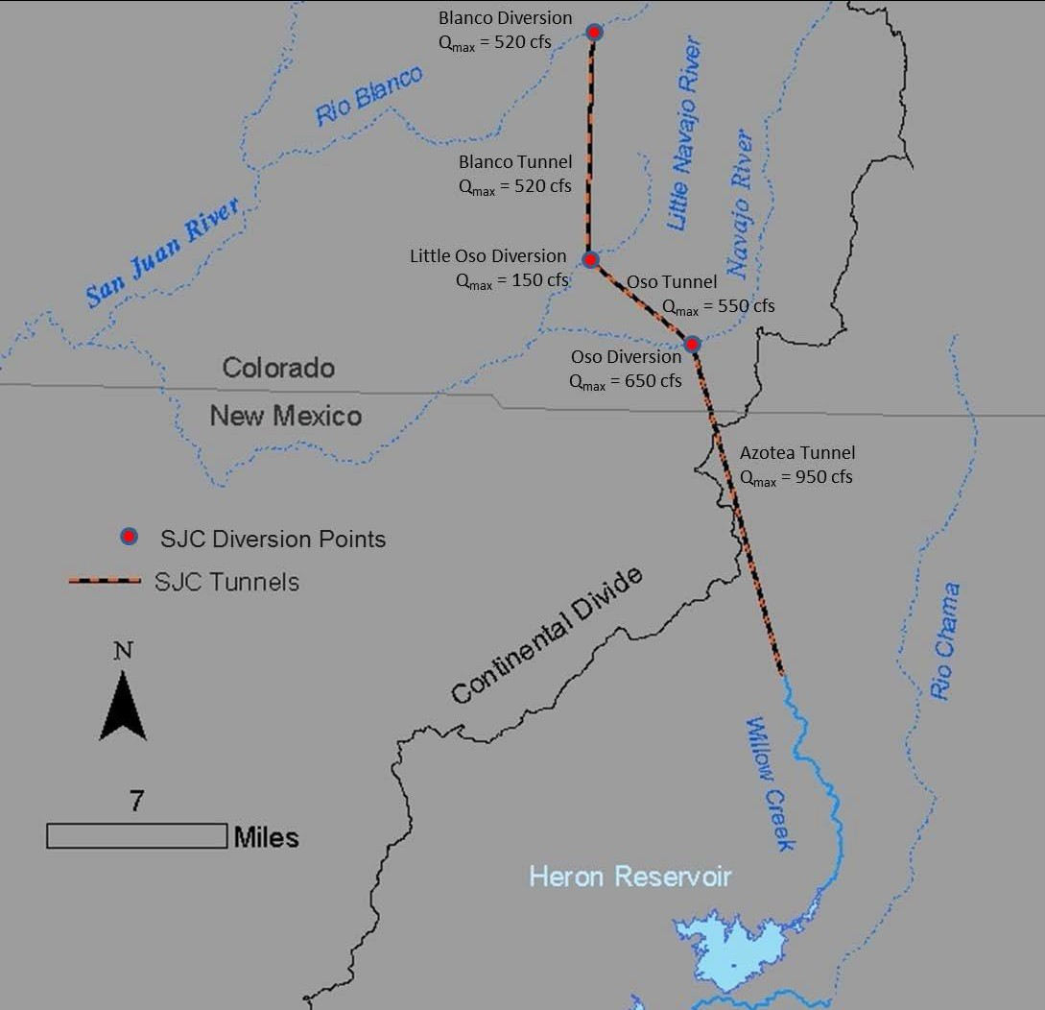

**Figure 8: The San Juan – Chama project diversion and tunnel locations and capacities**

Water is diverted based on the capacity restrictions of the diversion facilities while assuring the minimum bypass flows in the San Juan tributaries shown in Table 1. There is a maximum diversion volume allowed in any year and over any 10-year period. The water is conveyed by gravity through tunnels to Azotea Creek in the Rio Grande basin and flows into Heron Reservoir which is on Willow Creek. The total allocation is 96,200 acre-ft per year divided among contractors as shown in Table 2.

**Table 1: Minimum Bypass Flows at the San Juan Basin Diversions (cfs)**

|  |  |  |  |
| --- | --- | --- | --- |
| MONTH | RIO BLANCO  (Blanco Diversion) | LITTLE NAVAJO RIVER  (Little Oso Diversion) | NAVAJO RIVER  (Oso Diversion) |
| January | 15 | 4 | 30 |
| February | 15 | 4 | 34 |
| March | 20 | 4 | 37 |
| April | 20 | 4 | 37 |
| May | 40 | 27 | 88 |
| June | 20 | 27 | 55 |
| July | 20 | 27 | 55 |
| August | 20 | 27 | 55 |
| September | 20 | 27 | 55 |
| October | 20 | 4 | 37 |
| November | 20 | 4 | 37 |
| December | 15 | 4 | 37 |

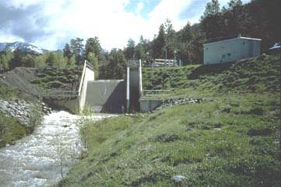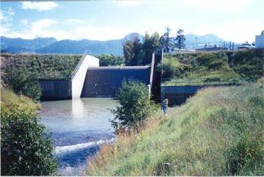

**Figure 9: The Little Navajo River (left) and Navajo River (right) downstream of the Little Oso and Oso diversion dams respectively (courtesy of Reclamation)**

The diversions from the San Juan River basin at the Blanco, Little Oso, and Oso diversions are computed in URGWOM with consideration for the total annual limit (270,000 acre-ft/year), limited diversion for a decade (1,350,000 acre-ft/10 years), available space at Heron Reservoir, minimum bypass flows at the diversion points, and the diversion and tunnel capacities. The annual and 10-year diversion limits are input to the SanJuanChamaRules data object. If the diversion is limited based on one of these criteria, a different algorithm may be used to compute each diversion if the total diversion will be less than 150 cfs. Otherwise, and if the diversions are not input, the diversions are set based on the input diversion capacities of 520 cfs for

the Blanco diversion, 650 cfs for the Oso Diversion, and 150 cfs for the Little Oso diversion and with consideration for the minimum bypasses shown in Table 1. The capacities for the corresponding diversion objects, and the minimum bypasses are input to the reach objects for the San Juan tributaries. Refer to the discussion for the San Juan Diversions rule in the San Juan Diversions Policy Group for more information on how the San Juan diversions are computed in the model.

**Table 2: San Juan Chama Project Water Allocations in URGWOM**

|  |  |
| --- | --- |
| (HeronData.SanJuanContractorAllocations) | Allocation (acre-ft/yr) |
| Albuquerque | 48,200 |
| MRGCD | 20,900 |
| Jicarilla | 6500 |
| City of Santa Fe | 5230 |
| Cochiti Rec Pool | 4290 |
| Taos Pueblo | 2215 |
| OHKAY Owingeh | 2000 |
| Los Alamos | 1200 |
| Aamodt Settlement | 1079 |
| PVID | 1030 |
| Espanola | 1000 |
| Belen | 500 |
| Bernalillo | 400 |
| Town of Taos | 400 |
| Los Lunas | 400 |
| Santa Fe County | 375 |
| Town of Taos Settlement | 366 |
| Red River | 60 |
| El Prado | 40 |
| Taos Ski Valley | 15 |
| Total Allocation | 96,200 |

San Juan water is allocated to contractors on January 1 of each year if water is available. The contracted allocations (Table 2) are input to the SanJuanContractorAllocations table slot in the HeronData data object. If the storage in the federal pool at Heron Reservoir is greater than the total allocation for all contractors, the full allocation is then made to all the contractors. Otherwise, the contractors receive a portion of the common pool for San Juan-Chama Project water based on the ratio of their contracted allocation to the sum of the contracted allocations for all the contractors. Additional allocations up to the contracted total allocation are made in the same manner on a subsequent date (e.g., July 1) if full allocations could not be made on January 1. Refer to the discussion of the SetSanJuanContractorAllocations and SetAdditionalSanJuanContractorAllocationsIfNeeded rules in the SJC Accounts Set Up Policy Group for more details on how these allocations are made in the model.

Within the model, separate accounting is included to track San Juan-Chama Project water versus native Rio Grande water throughout the system as San Juan-Chama Project water is delivered to contractors or to storage accounts. Heron Reservoir is only authorized to store San Juan-Chama Project water, so native Rio Grande water must be bypassed. The contractors do not have dedicated storage space at Heron Reservoir, so if contractors have not called for their water by December 31, they lose their allocation and it remains in Heron Reservoir as part of the project supply, or the common pool (i.e., there is no carryover of annual allocations). The Bureau of Reclamation (Reclamation) may issue waivers to allow for contractors to store water in Heron Reservoir until as late as September 30th of the following year. San Juan-Chama Project water will not be released from Heron Reservoir if it is spilling or it has full ice coverage as determined with the HeronSJReleaseRestrictions rule.

Contractors for San Juan-Chama Project water may cause depletions in the basin and then use allocated San Juan-Chama Project water to pay back the river. Actual paybacks are determined by the Office of the State Engineer using the groundwater models (depletions are generally caused by groundwater pumping) or other tools, and the deliveries are requested through letters from the Office of the State Engineer to Reclamation, hence the name “letter water deliveries.” Within URGWOM, the Exchanges Manager in RiverWare is used to establish debts for contractors to deliver water to pay back MRGCD as a paper water transfer at El Vado Reservoir, deliver the water from Abiquiu Reservoir as needed to contribute to meeting the MRGCD demand, or deliver the water from Abiquiu Reservoir to Elephant Butte during the winter to pay back the Compact depending on the model inputs. Separate accounting supplies are set up for the different payback options for each contractor.

San Juan-Chama Project water may be released from Heron Dam to fill downstream allocated storage space. Any water released from Heron Reservoir to storage space at Abiquiu Reservoir is simply passed through El Vado Reservoir. MRGCD will store San Juan-Chama Project water at El Vado Reservoir in the space available above the storage of native Rio Grande water. MRGCD may also allow for other contractors to use extra space at El Vado Reservoir where the water is temporarily stored up to an estimated amount that can be evacuated before the next runoff. MRGCD will keep their San Juan- Chama Project water in storage at El Vado Reservoir and deliver the water to meet the irrigation demand in the Middle Valley after all native supplies have been exhausted.

Some contractors have contracts to store San Juan-Chama Project water at Abiquiu Reservoir up to a pool elevation of 6220 ft with the majority of the space allocated to the Albuquerque Bernalillo County Water Utility Authority (Albuquerque). The actual allocated storage space decreases due to sediment accumulation. Albuquerque will store water until it is needed to meet the demand at their surface water diversion or for letter water deliveries. Deliveries of San Juan-Chama Project water from Abiquiu Reservoir are simply passed through at Cochiti Lake except for the San Juan-Chama Project water delivered to maintain the 1200 acre recreation pool at Cochiti Lake.

### Flood Control Operations

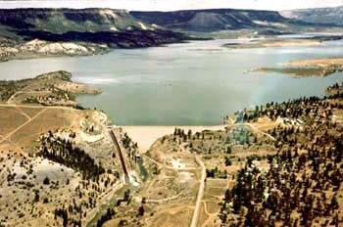

**Figure 10: El Vado Dam (courtesy of Reclamation)**

All the reservoirs are operated to comply with flood operations criteria and downstream channel capacities as possible. If the pool elevation at a reservoir exceeds a designated threshold, releases will be adjusted accordingly. If there is an unregulated spill, the releases will be reduced as possible per flood control policy to comply with the downstream channel capacities. Releases will also be adjusted to comply with stepped release restrictions as possible. The computed outflows include consideration for restrictions due to the physical constraints of the outlet works.

At Heron Reservoir, the change in the pool elevation over one day is restricted to be no greater than 1.0 ft. (Refer to the discussion of the HeronCheckDeltaStorage rule for more details). At El Vado Reservoir, if the pool elevation exceeds the maximum

allowable elevation of 6901.0 ft, the outflow will be set to the release required to reduce the pool elevation down to that maximum allowable elevation or the maximum possible release through the outlet works if that maximum possible outflow is lower (Refer to the discussion of the ElVadoFloodControl rule for more information). As a higher priority, the release will be restricted to be no greater than the downstream channel capacity of 5000 cfs (Refer to the discussion of the

ElVadoChannelCapacity Rule in the El Vado Reservoir Operations Policy Group).

At Abiquiu Reservoir, water will be “pre-evacuated” before April 30 if the forecasted inflow will increase the pool elevations at El Vado Reservoir and/or Abiquiu Reservoir over either of the corresponding maximum allowable elevations by a certain threshold. The pre-evacuation release is set to the average required release to evacuate the forecasted inflow before August 1. The stepped release restrictions as captured by the AbiquiuSteppedRelease rule and the downstream channel capacities of 1800 cfs below the dam, 3000 cfs at Chamita, and 10,000 cfs at Otowi as checked with the AbiquiuChannelCapacityRestrictions rule are higher priority. As an even higher priority, a maintenance outflow can be input to override normal operations (Such a maintenance flow would likely only be used to simulate a unique situation). If there is an unregulated spill at Abiquiu Reservoir, the releases will be reduced as possible to comply with the downstream channel capacities. The policy for Abiquiu Reservoir includes an additional stipulation that allows for water that was stored under flood operations to be carried over until after the irrigation season if such water is still in storage after Jun 30th, and the flow at Otowi drops below 1500 cfs. That carryover storage is then held in storage through the duration of the irrigation season and released from November 1 through March 31. These dates and thresholds can be changed in URGWOM to evaluate alternate operations including full release by December 31 in some years to count towards annual Compact deliveries.

Flood control operations at Cochiti Dam and Jemez Canyon Dam involve consideration for the combination of the outflows from each dam. The releases are adjusted based on the ratio of the available space at each reservoir to the total available space in both reservoirs to comply with the channel capacity at Central Ave., currently input as 7000 cfs, and San Marcial, currently input as 6000 cfs (Refer to the CentralChannelCapacityRule, SanMarcialChannelCapacityRule, JemezSanMarcialChannelCapacity, and CochitiChannelCapacityRestricions rules in the Cochiti and Jemez Reservoir Operations Policy Group). The channel capacity at San Marcial is lower due to the current constraint at the railroad bridge. Stepped release restrictions at both Cochiti Dam and Jemez Canyon Dam as captured by the CochitiSteppedRelease rule are higher priority. If necessary, releases will be adjusted to balance operations as stipulated in the water control manuals for each facility using the CochitiWCMBalancedRelease rule. If there is an unregulated spill at Cochiti Dam, the release through the gates will be reduced to comply with the downstream channel capacity as possible using the CochitiFloodControl rule.

### Rio Grande Compact

Equations are coded into expression series slots in the RioGrandeCompact data object (and RioGrandeCompactMonthly data object) in the model for completing New Mexico calculations for the Compact (New Mexico et al., 1938). The calculations involve determining the native Rio Grande flow at Otowi excluding San Juan-Chama Project water. The Otowi Index Supply is computed and the corresponding scheduled delivery to Elephant Butte Reservoir is determined. The actual delivery to Elephant Butte Reservoir is also computed. An annual net adjustment to the Compact credit is calculated as the difference between the Elephant Butte Effective Supply and the scheduled delivery to Elephant Butte Reservoir. The annual net adjustment is applied at the end of each calendar year to the running Compact credit or debit. Evaporation losses are applied to a Compact credit during the year (but not a Compact debt). In the case of a spill at Elephant Butte, cumulative credits or debits are set to zero per the Compact.

#### Article VII of the Rio Grande Compact

Under Article VII of the Compact (New Mexico et al., 1938), it is stipulated that native Rio Grande water cannot be stored in post-1929 reservoirs when the Usable Water in Project Storage is less than 400,000 acre-ft. This does not apply the Prior and Paramount (P&P) storage for the six Middle Rio Grande pueblos as discussed in Section 4.2.4.3. The Usable Water in Project Storage is computed with the ComputeUsableStorage rule and includes the total storage at Elephant Butte Reservoir and Caballo Reservoir minus credit water stored at Elephant Butte Reservoir, as of December 31, and any San Juan- Chama Project water as tracked in the accounting. The amount of Usable Water in Project Storage is also updated for any relinquished Compact credits as discussed in the next section. For each timestep in the model, a switch is set with the SetCompactArticleVIISwitch rule to identify whether the stipulations of Article VII of the Compact are in effect for that day. That switch is then referenced throughout the

ruleset. Article VII status affects storage of native Rio Grande water at El Vado Reservoir, as well as Nichols and McClure Reservoirs which are not modeled in URGWOM).

#### New Mexico Relinquished Credits and Emergency Drought Water

Following historical practice, if New Mexico has a positive Compact balance (credit water in storage at Elephant Butte), URGWOM allows for relinquishment of this water in exchange for credits for future storage of “Emergency Drought” water in El Vado during Article VII conditions. (See Section 2.1.1 for additional discussion.) If this aspect of policy is modeled for New Mexico, the assumption is that Compact credits exceeding a specified threshold will be relinquished annually to reduce the credit to a specified level after the relinquishment (SetRelinquishedCompactCredits rule). The magnitude of a relinquishment can also be specified. Allocations for subsequent storage of Emergency Drought water at El Vado Reservoir are set in the UpdateEmergencyDroughtStorageAllocations rule based on input fractions (summing to one) of the relinquished credit for each of three purposes: MRGCD, Endangered Species Act (ESA), and municipalities.

Inflows of native Rio Grande water to El Vado Reservoir when Article VII is in effect are then stored to separate accounts for Emergency Drought water after any P&P storage requirement is met first (Refer to Section 4.2.4.3 for more information on P&P storage). Storage accumulates in the Emergency Drought accounts with the actual inflow of native Rio Grande water. The allocation for storage of Emergency Drought water for municipalities can be tracked but is not currently used since exact policy for how such water would be used by municipalities has not been defined. MRGCD water is used to meet their diversion demand, and ESA water is used to meet target flows in the Middle Valley.

### Diversions

Diversions are set in the MRG portion of URGWOM for diversions on the Rio Chama, the four main MRGCD diversions, the Albuquerque surface water diversion, and the Buckman Direct Diversion.

#### Rio Chama Diversions/Acequias

There are five aggregate diversion site objects in the model that represent diversions from the Rio Chama. The Scull and Monastery diversions are included together in an aggregate diversion site object above Abiquiu Reservoir. Diversions to 13 different acequia systems occurs in an aggregate diversion site below Abiquiu Dam, the Chili diversion occurs next, from a separate aggregate diversion site, with returns occurring above the Chamita gage. Next, the Chamita and Hernandez diversions are combined in an aggregate diversion site where the diversion occurs above the Chamita gage, but the returns occur below. Finally, the Salazar diversion occurs from a final Rio Chama aggregate diversion site below the Chamita gage. A minimum native outflow is maintained at El Vado Dam (the minimum of El Vado Rio Grande inflow or 100 cfs) and bypassed at Abiquiu Dam during the irrigation season to assure these acequias receive the water they are entitled to.

The diversion and depletion requested for each individual diversion is set in the initialization rules. The fractional return flow is currently set at 0.33 for all the Rio Chama diversions for all months, meaning the depletion request is 67% of the diversion request.

#### MRGCD Diversions

Diversion requests by MRGCD at Cochiti, Angostura, Isleta, and San Acacia are set in the initialization rules (more detail on the Initialization ruleset is documented in Volume 2a of the URGWOM Documentation). Diversions from the Rio Grande below Cochiti Lake to the Sili and Eastside Main canals are subtracted in the model immediately below Cochiti Dam. Diversions at Angostura to the Atrisco Feeder and Albuquerque Main Canal are subtracted using the AngosturaDiversions aggregate diversion site object. The input diversions to the Belen High Line Canal and Peralta Main Canal along with the Cacique Acequia, Chical Acequia, and Chical Lateral are subtracted at the Isleta diversion. The requested diversions to the Low Flow Conveyance Channel at the San Acacia diversion dam are also based on input to the MRGCD data object. Diversions to the Socorro main canal are set with consideration for flows from the Unit 7 drain.

Releases from upstream storage for the MRGCD diversions are set with reference to a single demand at Cochiti Lake. The demand curve reflects the use of return flows at downstream diversions. Native Rio Grande water in storage at El Vado Reservoir is released if available to meet MRGCD demand at Cochiti not met by Rio Grande mainstem supply. Available Emergency Drought water is used next, and MRGCD San Juan-Chama Project water is used after all native supplies have been exhausted.

When MRGCD is in a shortage situation which is indicated when the MRGCD Demand at Cochiti cannot be met with the river flow or the available water in storage for MRGCD, diversions at Angostura are then increased from the regular diversion requested values to the total canal capacity of 400 cfs. This adjustment is completed with the ResetAngosturaDiversionForShortageOps rule. These increased diversions reflect adjustments in MRGCD operations during shortage situations to use the limited supply as efficiently as possible.

#### Six Middle Rio Grande Pueblos

There are six Middle Rio Grande Pueblos (Pueblos) : Cochiti, Santo Domingo, San Felipe, Santa Ana, Sandia, and Isleta. Reservoir operations may entail releasing water if the direct flow supply is insufficient to irrigate the 8,847 acres of Prior and Paramount (P&P) irrigated land at the pueblos. The Pueblos irrigation season runs from March 1 to November 15. Irrigated acreage for the Pueblos is not distinguished from MRGCD land in URGWOM and diversions to the Pueblos are included with MRGCD diversions; however, the storage and release of P&P water for the Pueblos to assure the P&P demand is met is tracked separately in URGWOM.

An initial P&P storage requirement is computed on March 1 (and updated on April 1 and May 1) with the ComputePandPStorageRequirement rule to set the storage required to meet the demand for the remainder of the irrigation season. The storage requirement includes additional storage needed for any

dead storage (or unavailable storage below the outlet works) at El Vado Dam. The P&P storage requirement is computed based on the approach implemented by the Bureau of Indian Affairs (BIA) and Reclamation and is currently based on the data and procedure developed in 2003.

The storage requirement is computed as an estimated storage required to meet a monthly demand for the remainder of the year minus the estimated flow that will be available for the remainder of the year as computed with reference to an Otowi forecast volume. A release is made from P&P storage at El Vado if the flow from the mainstem, based on the modeled flow at Embudo, would not meet the demand for the pueblos. This release is made independently of the available supply for MRGCD. The needed release is computed with the rules in the ComputeCallForPandPRelease policy group.

For AOP applications, the required storage for P&P is typically hand input (based on a coordinated agreement between BIA and Reclamation) to override the computed value.

#### Albuquerque Diversion

The Albuquerque diversion is set up as a water user object in URGWOM, and the diversion requested is computed with rules in the SetAlbuquerqueDiversion policy group. The diversions are generally set to double the full demand for Albuquerque San Juan-Chama Project water as input to the AlbuquerqueDiversions data object, with a 50 percent return flow credit for the native water that is diverted, unless it is determined that the diversion should be curtailed or cut off per the diversion permit. Following the diversion permit, URGWOM begins to curtail Albuquerque diversions of native water when native flows at Central go below 135 cfs with complete shutoff of native diversions when native flows at Central reach 70 cfs or less. If native diversions are subject to curtailment, total diversion demand may be met with additional San Juan-Chama Project water if a switch is set in the model. Also, if San Juan-Chama Project water cannot be delivered because of flood control operations at Abiquiu, diversions may be met with additional Rio Grande water to be paid back with an exchange for San Juan- Chama Project water at Elephant Butte Reservoir if another switch is set.

URGWOM policy also includes a check against preemptive cutoff criteria where a preemptive cutoff is implemented before actual permit restrictions would result in curtailed diversions or also during high flows. The preemptive cutoff represents the assumption that Albuquerque would switch to groundwater during low flows before curtailment per the permit would occur or during high flows when it may be unsafe or impractical to operate the diversion dam or when flood control operations at Abiquiu or Cochiti might prevent Albuquerque from receiving a delivery of their allocated San Juan-Chama Project water. The high flow thresholds for a preemptive diversion cutoff are set to 1800 cfs out of Abiquiu or 4500 cfs out of Cochiti. The threshold low flow for a preemptive cutoff is 200 cfs and diversions will not restart until at least two weeks after any preemptive cutoff criterion is not satisfied and the flow at Central is greater than 250 cfs.

Releases of Albuquerque’s San Juan-Chama Project water from Abiquiu are generally set to provide the smaller of 65 cfs or half of Albuquerque’s total surface water demand, with transit loss rates applied.

The loss rate is based on the San Juan-Chama loss rate of 1.23 percent from Abiquiu to Cochiti and monthly loss rates from Cochiti to the diversion. Wastewater returns from Albuquerque are set as an

input based on historical data and are not affected by a cutoff to the surface water diversions as actual wastewater returns are not dependent on whether surface water or groundwater is being used to provide drinking water. Assumed returns range from approximately 77.5 cfs to 83.4 cfs (slightly more than half of the diversion).

#### Buckman Direct Diversion

The Buckman Direct Diversion is modeled with a water user object for the diversion to Santa Fe below the Otowi stream gage. Diversions are modeled based on an assumed average rate for the future for Santa Fe City and Santa Fe County to use their allocations of San Juan-Chama Project water, and an average rate for diversion for native Rio Grande water is included based on water rights that may be in place for each. Portions of Rio Grande water diverted for the mixing operation at the diversion are also included for each and return flow fraction is computed for the immediate return of this portion of the diversion. Criteria for the curtailment or cutoff of the diversions of native Rio Grande water are modeled. The diversions and fraction return rate are set with the rules in the SetBuckmanDiversion policy group.

### Downstream Target Flows

Releases of supplemental water for flow targets at Central, Isleta, San Acacia, and San Marcial can be made in the model with consideration of the physical losses as represented by all the different methods in the model. Supplemental water consists of leased San Juan-Chama Project water or Emergency Drought water stored at El Vado Reservoir that is specifically designated for targets.

Targets are input to a table and established for hydrology year types: dry, average, or wet. Targets in the table may be adjusted based on an input adjustment factor. A step down in targets after the continuous flow requirement is included in the current target table, and additional step downs at Isleta, San Acacia, and San Marcial may be implemented for discretionary operations as discussed further in Section

4.2.5.3. Targets are identified at each timestep using the MinCentralTarget and MinIsletaSanAcaciaSanMarcialFlow Targets rules. The Central targets may be modified to provide recruitment or overbank flows as part of Cochiti deviations.

#### Hydrology Year Type

The year classification for setting targets in the model is set using the Hydrology Year Type rule based on a March through July forecasted flow volume at Otowi calculated with reference to input inflows. This approach essentially matches the actual approach of referencing the runoff forecast. The year will be classified as dry or wet if the forecasted flow volume is less than 80% of the average Otowi flow volume or greater than 120% of average, respectively. The determined year classification on May 1 is maintained for the remainder of a calendar year. A year is classified as dry regardless of the forecast if the stipulations of Article VII of the Compact are in effect, but since the year classification is set for the remainder of the year on May 1st, the year classification will not change if the Article VII status changes

after May 1st. The Hydrology Year Type was necessary for 2003 Biological Opinion based operations. The more recent 2016 Biological Opinion is less prescriptive, and currently (2019) target operations in URGWOM remain based to some degree on the targets from the 2003 Biological Opinion, but the targets used are the same in all years, so the Hydrology Year Type is not currently utilized for MRG flow targets.

#### Adjustment Factor Target Operations

An adjustment factor is included in URGWOM to increase targets by a percentage (i.e. a target of 100 cfs will increase to 125 cfs with a 25% adjustment factor). A 25% adjustment factor is currently applied to targets because the model can set releases from Abiquiu to hit targets in the Middle Valley with much better precision than can be done in actual operations. Uncertainty about conveyance losses, MRGCD returns, local inflows, etc. combined with the travel time from Abiquiu Dam to target locations and other physical operational constraints prevent actual releases from being adjusted with such precision, so an adjustment factor is applied to targets in the model such that modeled supplemental water releases more accurately reflect actual release volumes. Rules are also added to Abiquiu operations to round target releases and hold releases steady for a threshold number of days before resetting. These operations reduce the precision of simulated target releases in favor of more realistic operations. For example, where URGWOM might initially choose to release 93.45 cfs, 113.42 cfs, and 123.54 cfs from Abiquiu during three consecutive days to exactly meet a flow target at Central, the adjustment factors might change these releases to 120 cfs each day for three days, and the downstream flow target would not be exactly met. The steady 120 cfs releases would be more similar to actual operations where the impact of releases on the downstream flow is not perfectly understood a priori.

#### Discretionary Operations

URGWOM is set up to simulate discretionary operations as part of the 2003 BO which entail using supplemental water to manage the recession after the runoff and control the rate of drying after river rewetting for minnow salvage. Coded policy for representing discretionary operations entails implementing a 30-day step down in targets at the end of the runoff and 7-day step downs in targets thereafter following each river rewetting event. Magnitudes for the initial flow for the step downs in targets are set to 50, 100, and 50 cfs for initial targets at Isleta, San Acacia, and San Marcial with targets decreasing to zero in five steps for the initial 30-day step down and 7 steps for the subsequent 7-day step downs. Switches are included in the model such that the two separate implementations of step downs in targets can be turned on or off. Although the 2003 BO has been superseded, the more recent BO is less prescriptive, and Reclamation is currently (2019) still operating to meet minimum flows at Central, Isleta, San Acacia, and San Marcial, and to manage initial recession in the river. As a result, existing URGWOM capabilities are still relevant for discretionary supplemental water operations.

#### Supplemental Water Needed for Targets

Daily needed releases from Abiquiu Dam to meet targets at Central, Isleta, San Acacia, and San Marcial are computed in the model using either computationally intensive hypothetical simulations, a simpler alternate set of calculations, or rules developed in 2022 based on agreements between Reclamation and MRGCD (discussed further below). Hypothetical simulations in RiverWare are separate side simulations of a portion (subbasin) of the larger model. In this case, four separate hypothetical simulations are made using portions of URGWOM from Cochiti to the target location in question with consideration for all MRGCD diversions and estimated returns and any diversions by Albuquerque to determine needed releases for the downstream targets.

The hypothetical simulations allow high precision but are computationally intensive. Because this precision is not necessarily representative of actual operations, and because of the computation burden, an alternative approach to calculation of targets that is both less accurate and less computationally intensive has been developed. This approach for identifying the flow needed at Cochiti for each of the four Middle Valley target locations estimates evaporation, seepage, diversions, and returns, and Jemez inflows to the river based on future dates where data is available, or averages of previous timesteps otherwise. In addition to efficiency improvements, this alternate approach is more similar to the way actual operations are conducted. This approach is used if a switch is set by the model user to use the alternate approach.

Once the flow at Cochiti necessary for each target has been determined (either with hypothetical simulation, or the alternate approach) the largest of the four flows is set as the necessary Cochiti release. This target release represents the total flow needed for targets including water needed for MRGCD and Albuquerque diversions. A hypothetical simulation is then completed for the segment of the model from Abiquiu Dam to Cochiti Lake to determine the total flow needed from Abiquiu Reservoir to meet the release demand at Cochiti.

If the 2022 agreement between Reclamation and MRGCD is not being used, the amount of supplemental water needed from Abiquiu is computed by subtracting the release of native Rio Grande water, letter water deliveries, any release of MRGCD San Juan-Chama Project water, the release of Albuquerque’s San Juan-Chama Project water for the surface water diversion, and deliveries to the Buckman Direct Diversion from the determined total flow needed at Abiquiu for targets. The resulting amount of supplemental water needed varies daily based on the estimated physical losses, but in order to approximate the uncertainty and daily stability of actual operations, the needed release of supplemental water is not adjusted until the supplemental water needed based on the physical losses has changed by more than 50 cfs and is not adjusted more than once every three days. The computational approach for adjusting the Abiquiu releases are configured such that the volume for the release of supplemental water approximately matches the volume of supplemental water needed based on the Cochiti release demand. There is a significant loss of precision as a result of these Abiquiu operational constraints. Certain URGWOM applications related to additional water requirements to meet targets may call for highly precise model runs. In these applications the modeler should disable the alternate calculation method for MRG targets as well as the ways in which Abiquiu operations are “dulled” to be more representative of actual operations.

If the 2022 agreement between Reclamation and MRGCD is being used, a different set of logic is used for determining the amount of supplemental water released from Abiquiu: If the previous flow at Central or San Marcial is less than the target flow, increase the supplemental water release from Abiquiu by this deficit. If the previous flow at Isleta is less than the target flow, set the supplemental water release from Abiquiu equal to this deficit. If the previous flow at San Acacia is less than the target flow, set the supplemental water release from Abiquiu equal to double this deficit. If the supplemental water release from Abiquiu is larger than what is being bypassed at San Felipe, Isleta, or San Acacia, then increase this bypass, but not let this bypass change too much from day to day.

The supplemental release from Abiquiu is restricted from dropping too much from day to day, to assist in gradual drying of a reach as opposed to a sudden drying of a reach.

#### Pumping from the Low Flow Conveyance Channel

URGWOM is set up to model pumping of flows from the Low Flow Conveyance Channel (LFCC) to the river to prevent river drying. Refer to Figure 11 for a picture of pumps used to pump from the LFCC. Diversions at the Neil Cupp site, North Boundary of the Bosque del Apache National Wildlife Refuge, and South Boundary are simulated (Pumping at the Fort Craig site was determined to be inconsequential to URGWOM simulation results and is not included). Water that seeps into the Low Flow Conveyance Channel is pumped to the river where pumping begins based on specific river flow triggers. Different triggers could be established as a function of the year classification for setting targets; although, the threshold low San Acacia flow triggers for initiating pumping at each site are the same in the current Operations ruleset regardless of the year type.

After pumping has initiated at a site, pumping will continue for a minimum of one week and until the flow at San Acacia has exceeded 150 cfs. Pumping will cease for the year at each site after input dates for each site. It is assumed in the current ruleset that pumps at the Neil Cupp site and North Boundary would not be used after June 30th. This aspect of operations can be turned off by setting the date to shut off pumping at each site to January 1st.

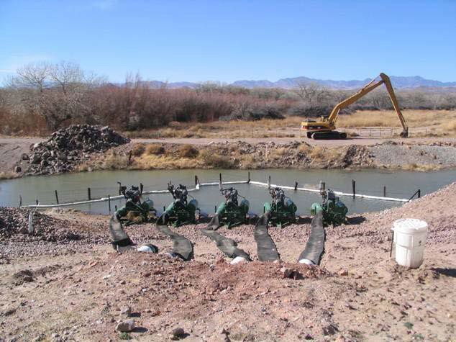

**Figure 11: Five Low Flow Conveyance Channel pumps ready to pump to the river**

### Recreation

There are two key recreation factors that affect policy in the basin. A portion of the San Juan water is used to maintain a permanent recreation pool of 1,200 acres at Cochiti Lake, and a rafting release from El Vado Dam may be modeled. The annual allocation of San Juan-Chama Project water for the Cochiti Rec Pool is 4,290 acre-ft, and the water is delivered to maintain a content of 44,140 acre-ft (based on the most current Elevation-Area-Capacity table) plus any sediment accumulation at Cochiti Lake which corresponds to a reservoir surface area of approximately 1200 acres. A switch is included in the model to either neglect the modeled sedimentation and target a fixed recreation pool volume, or alternately include modeled sedimentation and target the 1200-acre surface area.

The model is also set up to move contractor San Juan-Chama Project water from Heron Reservoir to Abiquiu Reservoir on certain days to provide rafting flows below El Vado Dam based on an input rafting flow schedule. These rafting release operations typically entail moving contractor San Juan- Chama Project water, as possible, on Friday through Sunday of summer weekends starting Memorial Day or by the July 4th holiday through Labor Day weekend. Rafting releases are modeled in URGWOM by moving contractor San Juan-Chama Project water from Heron Reservoir to Abiquiu Reservoir as needed to augment flows below El Vado Dam and meet rafting flow targets. This policy is only modeled if switches are set for a contractor to move the water to provide the rafting flows.

## MRG Reservoir Operations

For each dam modeled in URGWOM, there are three basic steps used to arrive at a final outflow and final value for individual deliveries. The initial deliveries are computed for individual contractor deliveries of San Juan-Chama Project water and for releases of native Rio Grande water. An initial total outflow is determined and then checked against physical and legal constraints where outflows can then be altered if not within the normal range of operations, either due to high flows (flood control operations) or low flows (minimum releases). Flood control operations tend to have the highest priority (i.e. lower rule number) because of safety and damage considerations. The outflow is set with consideration for flood control operation criteria if reservoir pool elevations exceed specific thresholds. The outflow will be restricted to comply with downstream channel capacities as possible, and stepped release restrictions may also be a priority. The computed total outflow will also be checked to assure it exceeds a designated minimum outflow. The determined final outflow is always checked to assure the release is physically possible based on the outlet works capacity for the dam. If there is an unregulated spill, the total release is adjusted as much as possible by using the regulated outflow through the gates at the dam. Given the reservoir pool elevation, the outflow may also be restricted based on the rating curve for the outlet works.

After the final total outflow has been set, a final reconciled outflow of Rio Grande and San Juan-Chama Project water is computed and used to identify the final values for individual deliveries and accounting supplies are set. (For most cases, the initial deliveries can be made with no adjustments needed for flood control operations or the physical constraints of the system). Refer to Appendix C for a flowchart of MRG policy and a depiction of the procedure used to ultimately set the reservoir outflows and individual deliveries at each timestep.

### Heron Dam

Releases of Rio Grande and San Juan-Chama Project water from Heron Dam under normal operations are computed with the ComputeHeronRGRelease and the ComputeHeronSJRelease Rules, respectively, and an initial total outflow is set to the sum with the HeronOutflow Rule. Rio Grande water is effectively bypassed, but actual operations entail making releases during the runoff and evacuating Rio Grande water during other periods after a certain amount of storage accumulates. These operations are replicated in URGWOM.

San Juan-Chama Project water is released from Heron Reservoir to fill downstream allocated storage space for contractors or to meet other contractor demands. If Heron is fully covered in ice, or the Heron pool elevation is greater than the Maximum elevation of 7186.1 ft and Heron Dam must spill, the release of San Juan water is reset to zero. The HeronSJReleaseRestrictions Rule implements these two criteria. Flood operation criteria are checked with the HeronCheckDeltaStorage Rule, and the final outflow of Rio Grande water is reconciled with the SetHeronRGAccount Rule. If the total release exceeds

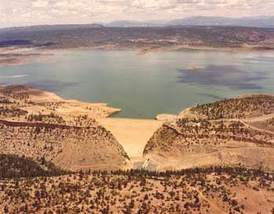

**Figure 12: Heron Dam & Reservoir (courtesy of Reclamation)**

the predetermined release of Rio Grande water, the Rio Grande outflow is reconciled to equal that lower total outflow. If the total release exceeds the sum of the predetermined release of Rio Grande and San Juan water, the Rio Grande outflow is reconciled to include that additional outflow.

### El Vado Dam

For El Vado Dam, the initial releases of Rio Grande and San Juan water are computed with the EstimateElVadoRGRelease and ComputeElVadoSJRelease Rules, respectively, and the initial total outflow is set as the sum of the two with consideration for a computed minimum release.

MRGCD San Juan-Chama Project water and native Rio Grande water is stored at El Vado Reservoir. Native Rio Grande water is stored if not needed to meet downstream demands, and

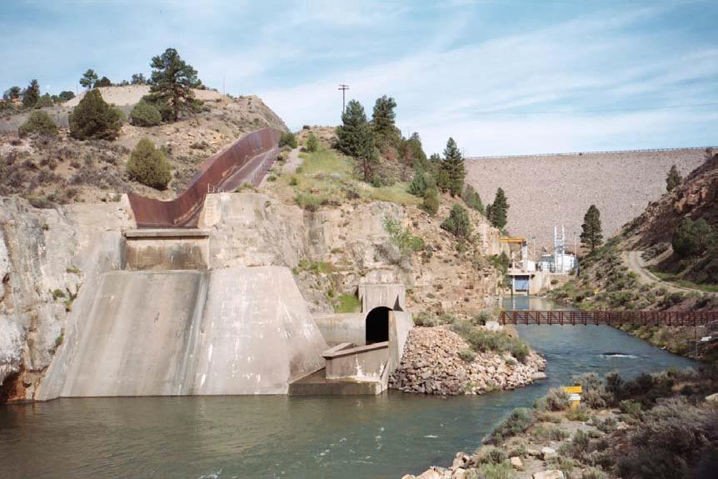

**Figure 13: El Vado Dam and Outlet Works**

Article VII of the Compact is not in effect. If Article VII is in effect, Rio Grande water can be temporarily stored in El Vado if there is an accrued debit in New Mexico’s deliveries to Texas and if approved by the Rio Grande Compact Commission. Otherwise, all native Rio Grande water is bypassed if not needed for P&P storage or Emergency Drought storage. Flood operations and the downstream channel capacities are checked with the ElVadoFloodControl and ElVadoChannel Capacity Rules, respectively, and the final outflow of Rio Grande water is reconciled with the SetAllRioGrandeAccountingSupplies Rule.

### Abiquiu Dam

Predetermined releases of Rio Grande and San Juan water from Abiquiu Dam are computed with the ComputeAbiquiuRGRelease and ComputeAbiquiuSJRelease Rules, respectively. The initial total outflow is set as the sum of the two. Rio Grande water is bypassed at Abiquiu Dam unless storage is required for flood control operations or is being modeled as proposed conservation storage. Releases of San Juan-Chama Project water include bypassed inflows and releases from storage for contractors to meet downstream demands including the Albuquerque surface water diversions and Buckman Direct Diversion. The predetermined total outflow is checked against a 25 cfs minimum outflow. The minimum required flow for the Rio Chama acequias during the irrigation season is maintained with the minimum flow out of El Vado Dam which is bypassed at Abiquiu Dam.

Any water stored for flood control operations may be locked in as carryover storage at Abiquiu Reservoir if flood water is still in storage after June and the flow at Otowi drops below 1500 cfs before the stored water can be evacuated. That carryover storage is then released after irrigation season is over. If it is determined that water needs to be evacuated at Abiquiu Reservoir in anticipation of large forecasted inflows, the outflow from Abiquiu Dam is reset based on a computed evacuation flow which includes consideration for the downstream channel capacity and stepped release restrictions (Refer to the AbiquiuPreEvacuation Rule). The stepped release and downstream channel capacity restrictions are checked with the AbiquiuSteppedRelease and AbiquiuChannelCapacityRestrictions Rules, respectively. Flood operations criteria are checked with the AbiquiuFloodControl Rule, and the final outflow of Rio Grande water is reconciled with the SetAbiquiuRioGrandeAccountingSupply Rule.

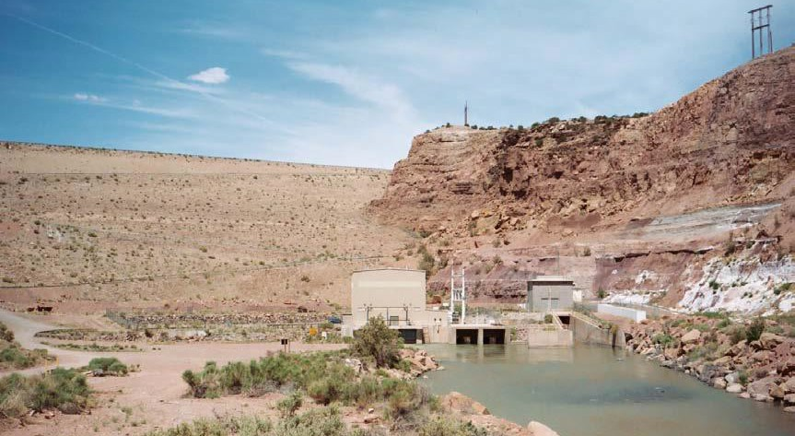

**Figure 14: Abiquiu Dam and Outlet Works**

### Cochiti and Jemez Canyon Dams

Releases from Cochiti and Jemez Canyon Dams are interrelated and to large degree are computed together. The initial releases of Rio Grande and San Juan-Chama Project water for both dams are computed with the rules in the Cochiti and Jemez Deliveries policy group. The total outflow from Cochiti Dam is set to bypass all inflows except native transfers to conservation storage or deliveries of San Juan-Chama Project water to the Cochiti Rec Pool. Consideration is also given to flood control storage locked in at Cochiti Lake until after the irrigation season (Refer to the discussion of Abiquiu operations in Section 4.3.3 above.).

The channel capacities at Central and San Marcial are checked with the CochitiChannel CapacityRestrictions rule with specific consideration for the combination of the flows from both Cochiti and Jemez Canyon Dams. Stepped release restrictions at Cochiti Dam are checked with CochitiSteppedRelease Rule, and the rule for balanced operations of Cochiti and Jemez Canyon Dams as identified in the water control manuals for each dam are checked with the CochitiWCMBalancedRelease Rule. Flood operations criteria are checked with the CochitiFloodControl Rule, and the final outflow of Rio Grande water is reconciled with the SetCochitiRGAccount Rule.

Inflows to Jemez Reservoir are bypassed.

#### Cochiti Deviations

Cochiti deviations were authorized for 5 years from 2009 through 2013. Under Cochiti deviation operations, the U.S. Army Corps of Engineers (Corps) may temporarily store native Rio Grande water in Cochiti to be released with peak inflows to augment downstream peak flows through the Middle Valley (USACE, 2009). Cochiti deviations are intended to benefit species listed under the Endangered Species Act by providing “recruitment flows”, defined as at least 7 consecutive days of flows greater than 3000 cfs at Central, or larger “overbank flows” defined as at least 5 consecutive days of flows greater than 5800 cfs at Central. Specific criteria are coded for identifying whether the runoff is sufficient to enact Cochiti deviations to provide recruitment or overbank flows, but insufficient without temporary storage at Cochiti Lake. Operations entail providing overbank flows if conditions support providing the higher flows. Cochiti deviations are not implemented if the simulation year is later than a model input specifying the last year that Cochiti deviations are authorized, currently set to 2013.

Deviations have been implemented in URGWOM to simulate recruitment flows if the March through July Otowi flow forecast is between 50% and 80% of average and the projected peak inflow to Cochiti Lake during the recruitment or overbank season is between 1800 and 5000 cfs or the March through July forecast is greater than 80% of average but the projected peak inflow is less than 3500 cfs. The projected peak inflow to Cochiti is estimated during an URGWOM simulation based on input inflows. Deviations will be implemented to provide overbank flows if the Otowi forecast is between 80% and 120% of average and the projected peak inflow to Cochiti is between 3500 and 10,000 cfs or the Otowi forecast is between 50% and 80% of average but the projected peak inflow is greater than 5000 cfs.

The date to start storage at Cochiti Lake for deviations can be input to URGWOM, but if no preset date is input, the default date to begin storage is set to 24 days before the projected date of the peak inflow to Cochiti Lake. Target flows to provide recruitment or overbank flows are input as 30-day target hydrographs. If deviations are implemented, targets at Central are reset such that day five in the appropriate target hydrograph matches the date of the projected peak inflow to Cochiti Lake (Refer to the ResetCentralTargetForCochitiDeviations and SetConservationSpaceAtCochiti rule).

Water in reregulation storage for Cochiti deviations is released as needed for targets where the needed release reflects the adjusted targets at Central to provide either recruitment or overbank flows.

Remaining water in reregulation storage will then be evacuated by the end of a deviations period which lasts for 45 days as currently input (ComputeCochitiRGConservationRelease rule). Water will begin to be evacuated 15 days before the end of the Cochiti deviations period at a constant rate if that constant rate is greater than the flow needed to meet targets. When the reregulation storage drops below 3000 acre-ft, targets are adjusted back to the original Central targets with the EndTargetsForOverbankOrRecruitment rule. This adjustment is needed to prevent other sources for supplemental water (i.e., leased San Juan-Chama Project water or Emergency Drought water) from being used to meet the recruitment or overbank targets.

# Lower Rio Grande Rules

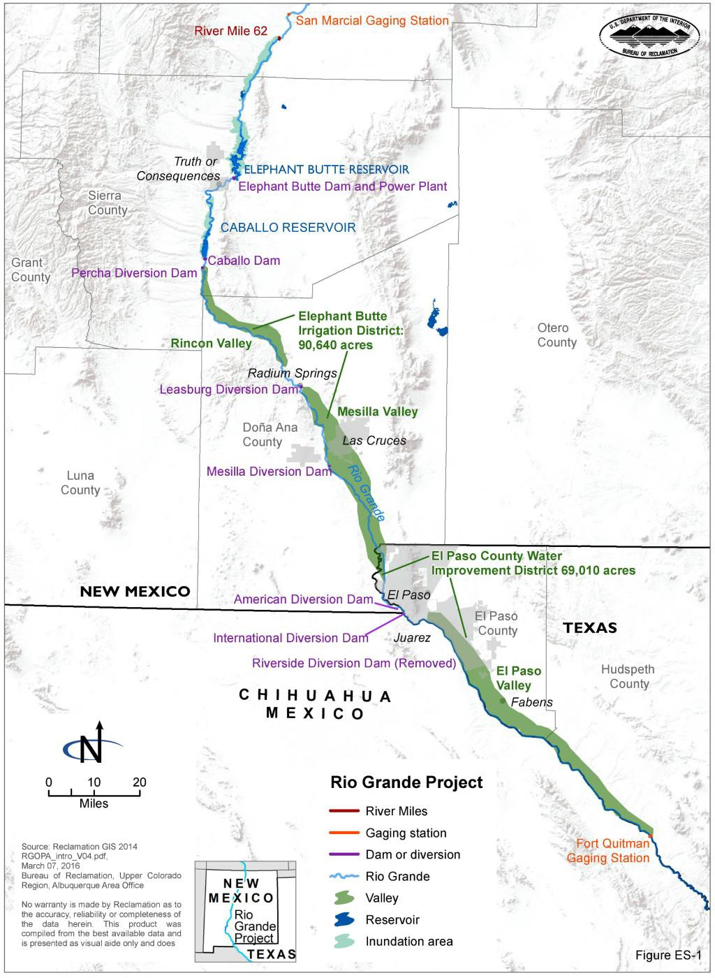The Lower Rio Grande (LRG) portion of the Upper Rio Grande Basin is characterized by two large reservoirs—Elephant Butte and Caballo—with agricultural diversions and groundwater pumping in New Mexico, Texas, and Mexico. In the LRG, URGWOM simulates flows along, diversions from, and returns to the Rio Grande from Elephant Butte reservoir to Hudspeth County, Texas.

**Figure 15: Map of the U.S. portion of the Lower Rio Grande area**

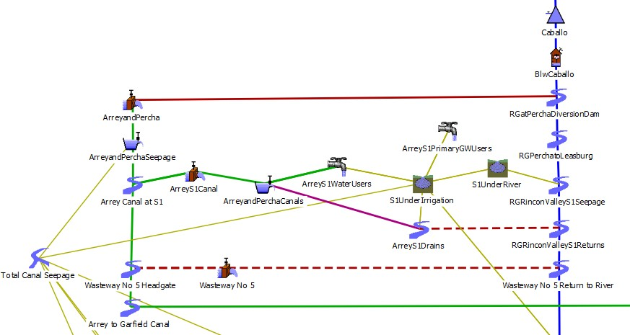

**Figure 16: Example portion of URGWOM in LRG**

## Introduction to LRG Rules

Within the URGWOM_9.3 Operations ruleset, there are 79 rules which determine LRG operations, and these rules are sorted into two different policy groups (See Figure 5). Rules colored red are associated with flood control, green with agricultural operations, blue with stream flows, orange with Compact operations, magenta with Rio Grande Project accounting, and purple with reservoir constraints.

Assignments for the different parameters are completed with each rule based on the priority for the rule. The rules are listed based on priority and are executed, or fired, in reverse order. For example, LRG Allocations rules at priority 79 – 52 fire before the higher priority LRG Project & Compact Accounting at priority 5 – 1. Thus, a release based on downstream demands can be reset by a higher priority flood control rule.

LRG diversion operations are driven by a combination of Rio Grande Project (Project) allocations, either crop demand-based or pattern-based river diversions and reservoir releases, and other reservoir operating policies.

For a flowchart of LRG rules logic, see APPENDIX D: Flowchart for Lower Rio Grande Policy. For RPL code specific implementation of URGWOM policy including the LRG specific rules, see APPENDIX H: Individual Lower Rio Grande Rules.

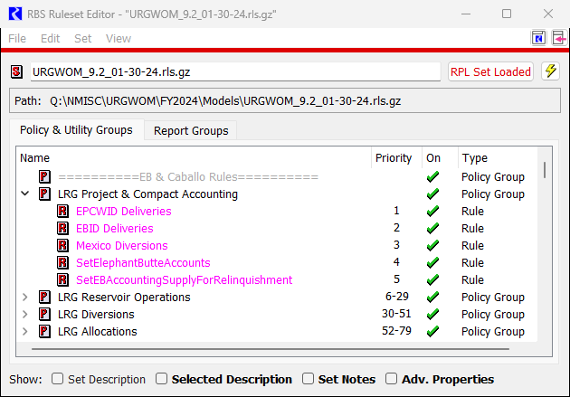

**Figure 17: Lower Rio Grande Operations ruleset Policy Groups**

## LRG Policy Controls

LRG operations in URGWOM are driven by Project allocations, agricultural diversions, and reservoir operations. These three policy drivers are each described in more detail in the following subsections.

### Rio Grande Project Allocations

In URGWOM, water supply allocations for Project contractors are made using empirically-derived relationships between water released from storage, water delivered to farms, and water available for diversion at river headgates. Two curves – the D1 and D2 curves – describe these relationships, and are based on historical data from the period 1951-1978. The procedures for determining District allotments and deliveries is detailed in “Rio Grande Project - Water Supply Allocation Procedures”.

The D3 operating procedures in URGWOM (from the 2008 Operating Agreement) makes adjustments to allocations for the Districts based on observed or estimated river efficiencies in making deliveries to river headgates, using a coefficient called the “Diversion Ratio”. A Diversion Ratio greater than 1.0 signifies that the river is net gaining from Caballo to Acequia Madre (i.e., total diversions are greater than Caballo release). A Diversion Ratio less than 1.0 indicates that river losses are greater than the sum of Caballo releases and any local inflows, return flows, and drain flows. The Diversion Ratio is first computed using an empirical equation, then estimated by using calculated efficiencies from the model, or can be manually input.

Allocations of Project water are made monthly during the irrigation season. The first step in allocating Project water is to compute any applicable carry-over volumes from the previous year; if these values are not already input. Total carry-over volume is limited for each irrigation district to 60% of the maximum annual allocation. Excess carryover volume above the 60% threshold is shared by the other district if it has available storage capacity in its carry-over account. Carryover volumes are set on each District’s account and may be available for use by the District depending on allocation of the current- year’s Project water.

The rules then determine how much (if any) of the Districts’ carryover water will be used in the current year. The amount of carryover water to be used in the current year will be added to the current year’s Project water allocation to determine a total release volume. Note that carryover water release volume is also subject to adjustment via the initial Diversion Ratio. If the Diversion Ratio is less than 1.0, more water than the carryover volume used will need to be released in order to deliver the appropriate carryover volumes at the river headings.

An initial allocation is made using the D1 and D2 curves. EPCWID receives an amount equal to its Project water allocation under D1 and D2, plus any carryover water for use in the current year. EBID receives an initial allocation also based on the D1 and D2 curves, but that allocation is adjusted either up or down depending on the Diversion Ratio value. If the value is greater than 1.0, then EBID and EPCWID split the excess allocation based on their relative percentages of total Project water allocation. If the value is less than 1.0, then EBID’s allocation is reduced by the fraction (1- DiversionRatio).

Once the final allocations have been made, these values get recorded on the District’s accounts as an “inflow” value. Together with any carryover from the previous irrigation season, this comprises the districts supply for the year.

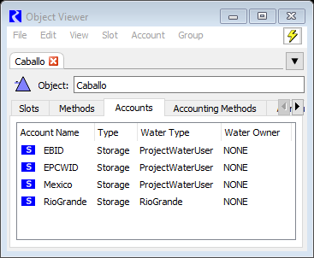

**Figure 18: Water Accounts for the Rio Grande Project on the Caballo Reservoir Object.**

### Pattern-Based Operations

The model user has the choice of using either Pattern-based rules to set diversion requests for river headings and water users, and set reservoir releases, or to use Demand-based rules (described in section

5.2.3 below).

If the model user chooses to use Pattern-based rules, these rules will set diversion requests for river headings and irrigation water users, set reservoir releases, and limits EPCWID diversions so that Acequia Madre demands are met.

There are 4 locations in the model at which Project water may be diverted by EBID and EPCWID:

* Arrey and Percha diversion
* Leasburg and Picacho diversion
* Mesilla diversion (both east and west-side headings)
* American diversion

At each location a diversion request is set each day of the simulation. The requests are computed using the annual District allotment (or Mexican allotment), multiplied by the annual pro-rata allocation to each river heading (Figure 19), and the daily distribution of diversions at each heading (Figure 20; example table for Leasburg and Picacho), which are conditioned on each year’s hydrologic type (wet, average, or dry), as measured by the available project water for that year, and a thresholds table (Figure 21).

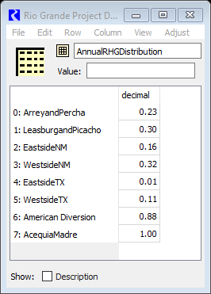

**Figure 19: Annual distribution of allocation to river headings for EBID, EPCWID, and Mexico.**

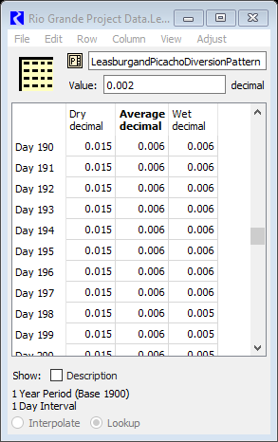

**Figure 20: Daily distribution of diversion requests for Leasburg and Picacho diversion**

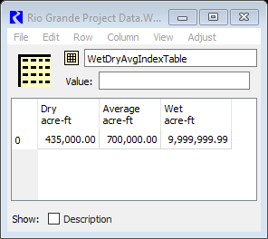

**Figure 21: Thresholds for WetDryAvg index**

Mexico’s water allocation is delivered at the International diversion dam. To ensure that demand is met, there is a check on the EPCWID diversion at American dam that will force a bypass of water if there is insufficient flow to meet the Mexican demand.

After setting the river heading demands, the rules set operational data for each of the diversion district sub-areas. The sub-areas are generally delineated by the groups of irrigation water users, canals, and wasteways that are served by a particular river heading. Beginning with the Rincon area irrigation water users (served by the Arrey and Percha diversion) and moving downstream, the model sets wasteway flows and irrigation water user requests. With Pattern-based operations, delivery of water to each heading is based on historical patterns, and so may not exactly match the total on-farm demands for irrigation water users in the service area. If the total water available for delivery (after losses and wasteway turnout) is less than the total on-farm demand, then deliveries are pro-rated based on each irrigation water user’s percent of the total irrigated acreage in that service area.

The Mesilla diversion dam supplies water through two canals to lands both east and west of the river. These canals also serve lands within both EBID (New Mexico) and EPCWID (Texas).

The rules attempt to meet the on-farm demand with the surface water deliveries described above, but if the available surface water is not enough, groundwater pumping will be used to meet the remaining on- farm demand. In the Rincon, Leasburg, and Mesilla valleys, this pumping is split between the shallow alluvial aquifer and the deeper confined aquifer that underlays it. Rules are used to specify the percentage of supplemental pumping that is sourced from each aquifer. In the EPCWID (below El Paso) and Mexico portions of the model, the pumping is all assumed to be from the shallow alluvial aquifer.

Unless user-input, releases from Caballo are determined based on a monthly pattern derived from historical release data (Figure 22). The pattern is conditioned based on each year’s hydrologic type (wet, average, or dry).

### Demand-Based Operations

If the model user chooses to use Demand-based rules, these rules will set diversion requests for river headings and irrigation water users, set reservoir releases, and limits EPCWID diversions so that Acequia Madre demands are met.

River headgate diversion requests are computed by summing the irrigation water user demands served by that headgate, plus losses due to canal seepage. This value is compared to the remaining District allotment, and if it exceeds the remaining allotment, the request will be curtailed pro-rata across the District’s headgates.

Mexico’s water allocation is delivered at the International diversion dam. To ensure that demand is met, there is a check on the EPCWID diversion at American dam that will force a bypass of water if there is insufficient flow to meet the Mexican demand.

After setting the river heading demands, the rules set operational data for each of the diversion district sub-areas. The sub-areas are generally delineated by the groups of irrigation water users, canals, and wasteways that are served by a particular river heading. Beginning with the Rincon area irrigation water users and moving downstream, the model sets wasteway flows and irrigation water user requests. If the

total water available for delivery (after losses and wasteway turnout) is less than the total on-farm demand, then deliveries are pro-rated based on each irrigation water user’s percent of the total irrigated acreage in that service area.

The rules attempt to meet the on-farm demand with the surface water deliveries described above, but if the available surface water is not enough, groundwater pumping will be used to meet the remaining on- farm demand.

Within the Demand-based rules, the model initially sets reservoir releases to zero. During any day of the irrigation season, this will result in shortages. Caballo releases are increased iteratively until either all diversion requests are met, or until the available project water is exhausted, in which case shortages for EBID and/or EPCWID will be distributed pro-rata across the river headgates, and subsequently across the irrigation water users.

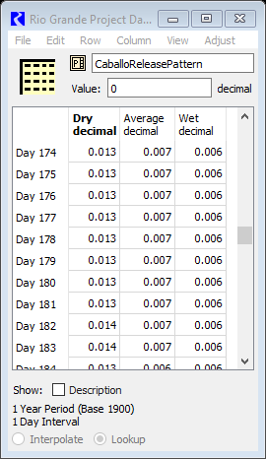

**Figure 22: Daily distribution of releases from Caballo reservoir**

|  |
| --- |
| C:\Users\Nick\AppData\Local\Microsoft\Windows\INetCache\Content.MSO\D08F00C1.tmp  **Figure 23: Elephant Butte dam (courtesy of Reclamation)** |

### Reservoir Operations

Unless user-input, releases from Elephant Butte are based on meeting a user-input storage target at Caballo. The rules then check if there is additional generator release capacity at Elephant Butte and increase releases if so. The rules then check for flood control operations at Elephant Butte and Caballo. Flood control operations only occur if the project or generator release is insufficient to drop the reservoir’s elevation below the flood control elevation at that reservoir. Regulated spills are limited to the channel capacities immediately downstream of each reservoir, and Caballo spills are limited to the channel capacity at Courchesne bridge in El Paso.

If instead of specifying a storage target the Caballo release are prescribed by user-input, there is the additional ability to set Elephant Butte releases for optimum power generation. When this feature is used, Caballo storage targets are set for winter and irrigation seasons based on storage levels in Elephant Butte. The rules will then determine the release level that meets the storage target while managing flow through the three generating turbines to produce the most power, based on an internal power performance table. Subsequent rules manage the release to consider preloading or drawing down Caballo near the start and end of irrigation season. Additional checks are in place to prevent release changes on the weekends (per USBR guidelines), to prevent fluctuations in Caballo elevations over two archeologic sites in Caballo Reservoir (Puskas and Animas), and to meet power generating guidelines specified by Western Area Power Administration (WAPA). Because power optimization only occurs when Caballo releases are user input, operations based on pattern or demand based operations are not considered.

# References

Cotten, C. (2015). Colorado Department of Water Resources Personal Email Communication March 14, 2015. Alamosa.

Cotten, C. (2017a). Colorado Department of Water Resources Personal Email Communication March 4, 2017. Alamosa.

Cotten, C. (2017b). Colorado Department of Water Resources Personal Email Communication March 5, 2017. Alamosa.

IBWC (1906). *Convention between the United States and Mexico* (Rio Grande Treaty) New Mexico, Colorado, & Texas. (1938). Rio Grande Compact.

New Mexico, Colorado, Utah, Arizona, & Wyoming. (1948). Upper Colorado River Basin Compact. Reclamation. (2016) *Continued Implementation of the 2008 Operating Agreement for the Rio Grande*

*Project, New Mexico and Texas. Final EIS*. Albuquerque

Reclamation. (2008). *Operating Agreement for the Rio Grande Project.* Albuquerque. Reclamation. (2007). *Operating Procedures for Rio Grande Project.* Albuquerque.

Sidlow, M. (2012). *Changes Made to Excel Spreadsheet File Flodspa7a*. Albuquerque. Udall, B. (1995). *COE Flood Spreadsheet Model*. Boulder.

USACE. (1963). *Platoro Dam Water Control Manual*. Albuquerque.

USACE. (2009). *Final Environmental Assessment For A Temporary Deviation In The Operation Of Cochiti Lake And Jemez Canyon Dam , Sandoval County , New Mexico*. Albuquerque.

# APPENDIX A: Flowchart for Input Data & Rio Grande Compact

This flowchart summarizes the overall flow of logic in the ruleset, and lists which rules are associated with this logic. This flowchart is not meant to represent exact methodology of implementation of the policy in RiverWare, but rather the location of specific rules within a general logic framework. All steps are completed at each simulation timestep unless noted otherwise in the flowchart.

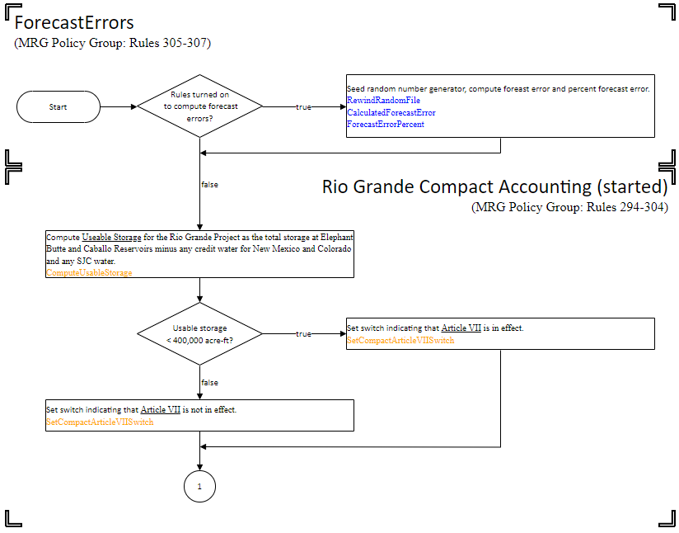Rule names are colored according to purpose in the ruleset and this flowchart:

Rules colored red are associated with flood control,

green with agricultural operations, aqua with municipal operations, blue with stream flows,

orange with Rio Grande Compact operations, magenta with ownership accounting, and purple with reservoir constraints.

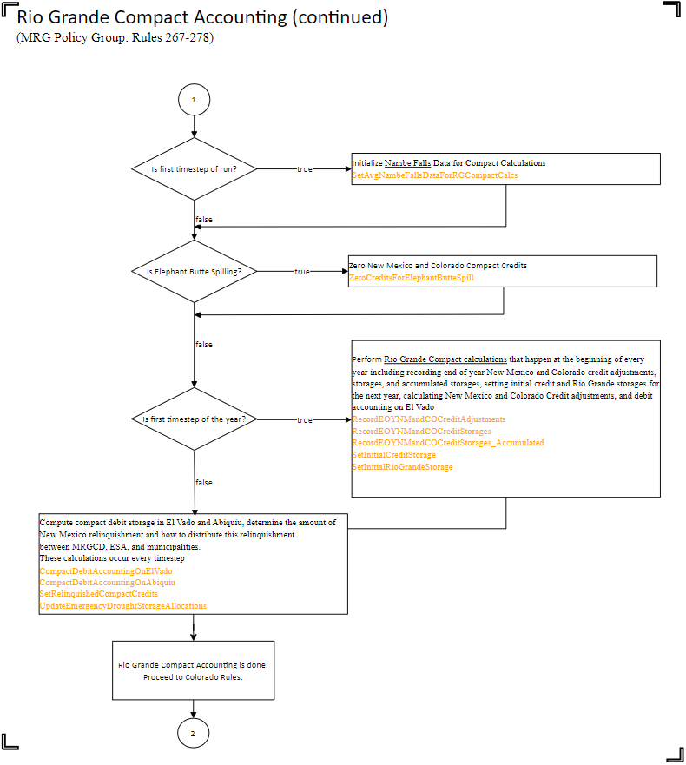

# APPENDIX B: Flowchart for Colorado Policy

This flowchart summarizes the overall flo w of logic in the ruleset, and lists which rules are associated with this logic. Th is flowchart is not meant to represent exact methodology of implementation of the policy in RiverWare, but rather the location of specific rules within a general logic framework. All steps are completed at each simulation timestep unless noted otherwise in the flowchart.

Rule names are colored according to purpose in the ruleset and this flowchart:

Rules colored red are associated with flood control,

green with agricultural operations, aqua with municipal operations, blue with stream flows,

orange with Rio Grande Compact operations, magenta with ownership accounting, and purple with reservoir constraints.

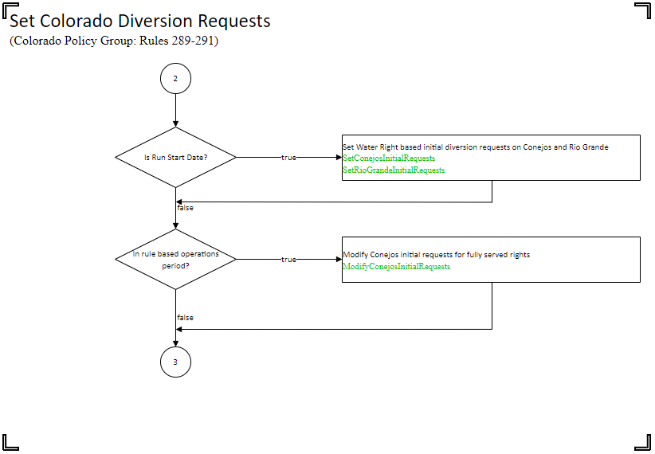

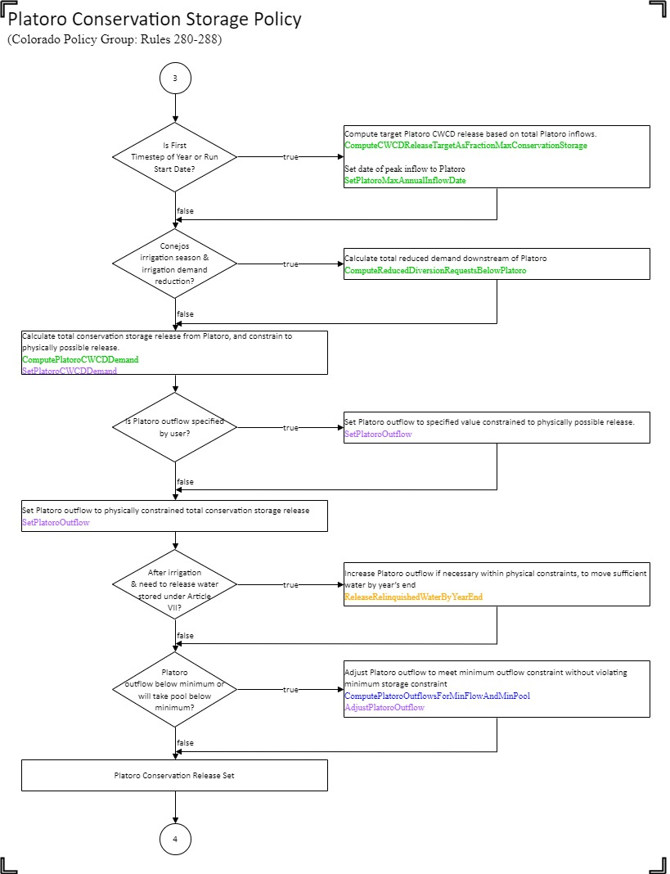

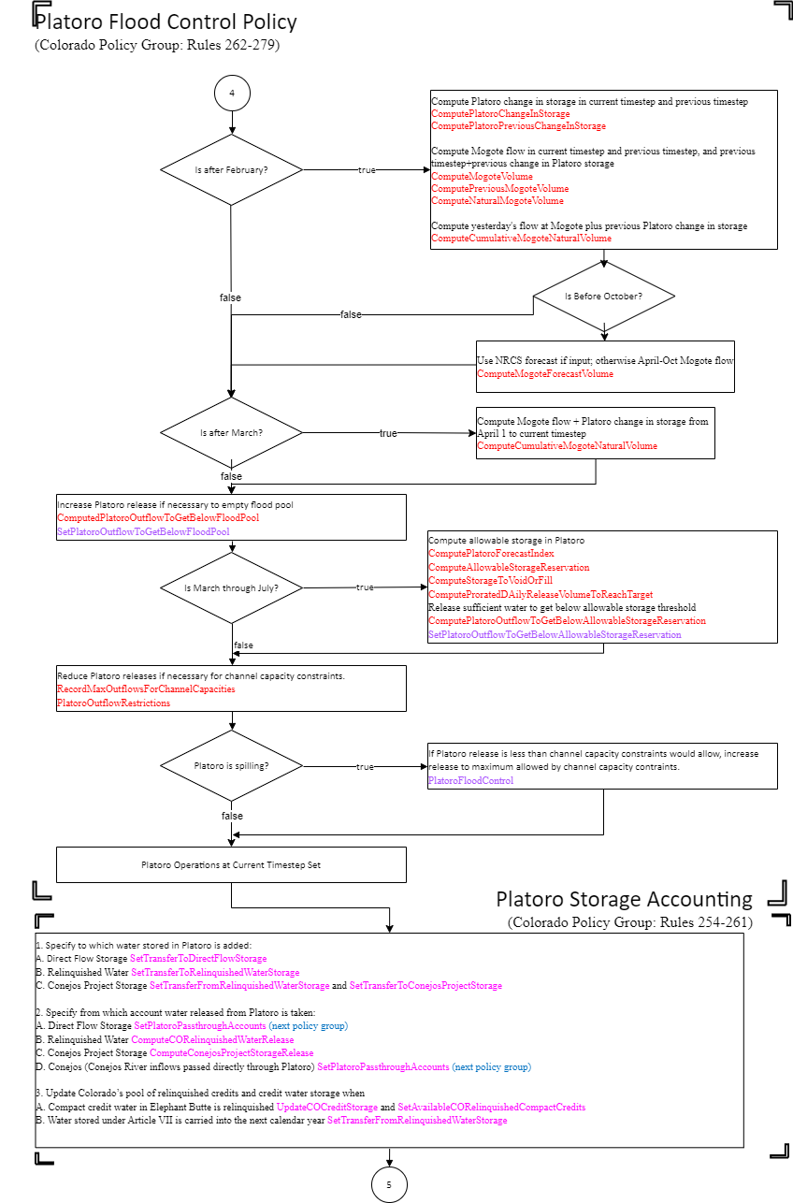

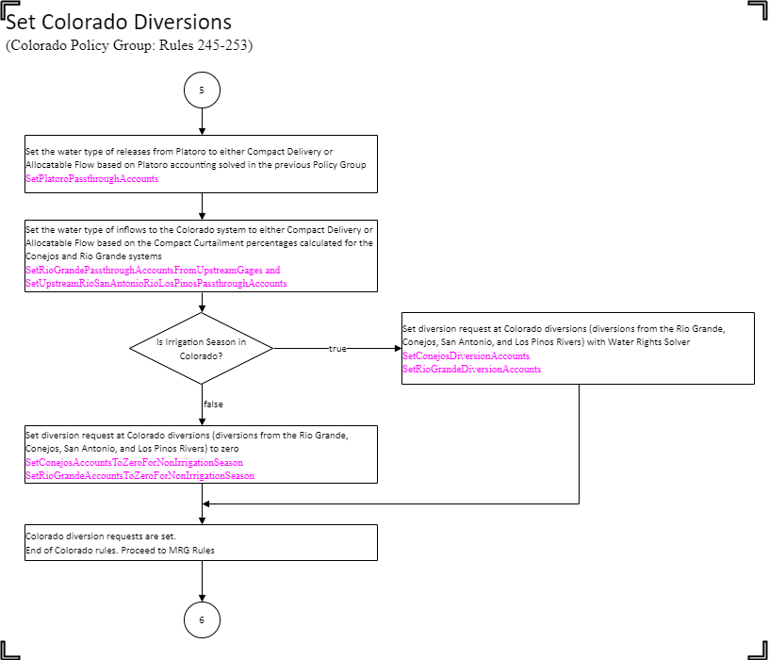

# APPENDIX C: Flowchart for MRG Policy

This flowchart summarizes the overall flow of logic in the ruleset, and lists which rules are associated with this logic. This flowchart is not meant to represent exact methodology of implementation of the policy in RiverWare, but rather the location of specific rules within a general logic framework. All steps are completed at each simulation timestep unless noted otherwise in the flowchart.

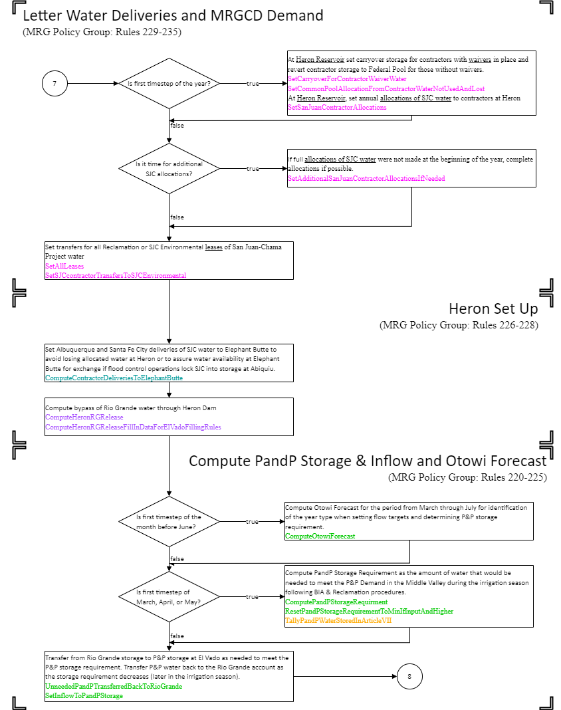

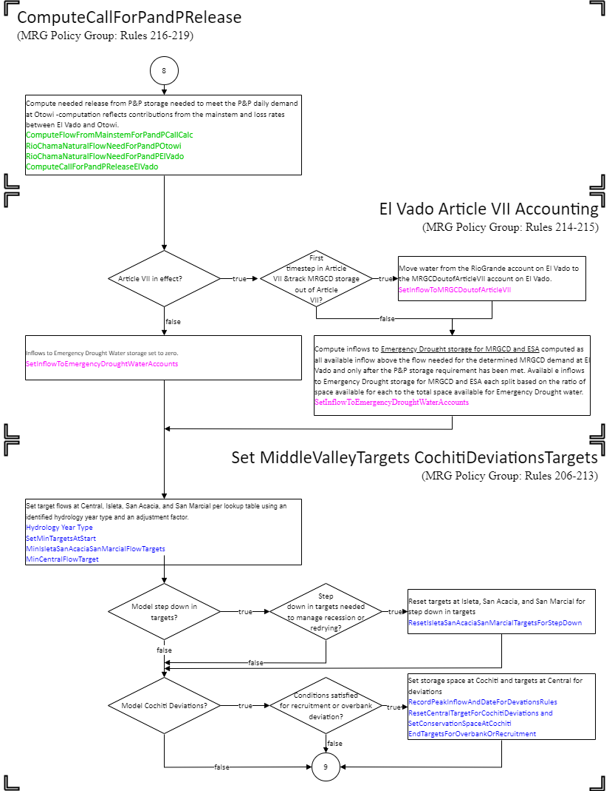

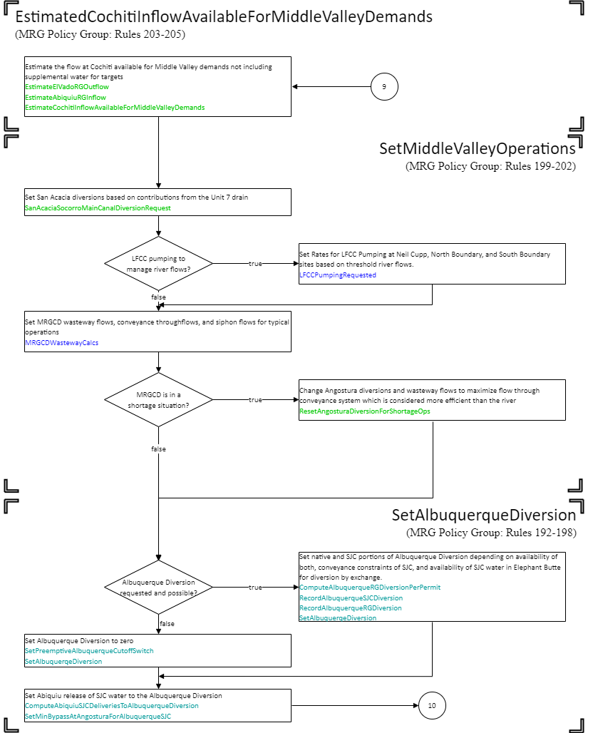

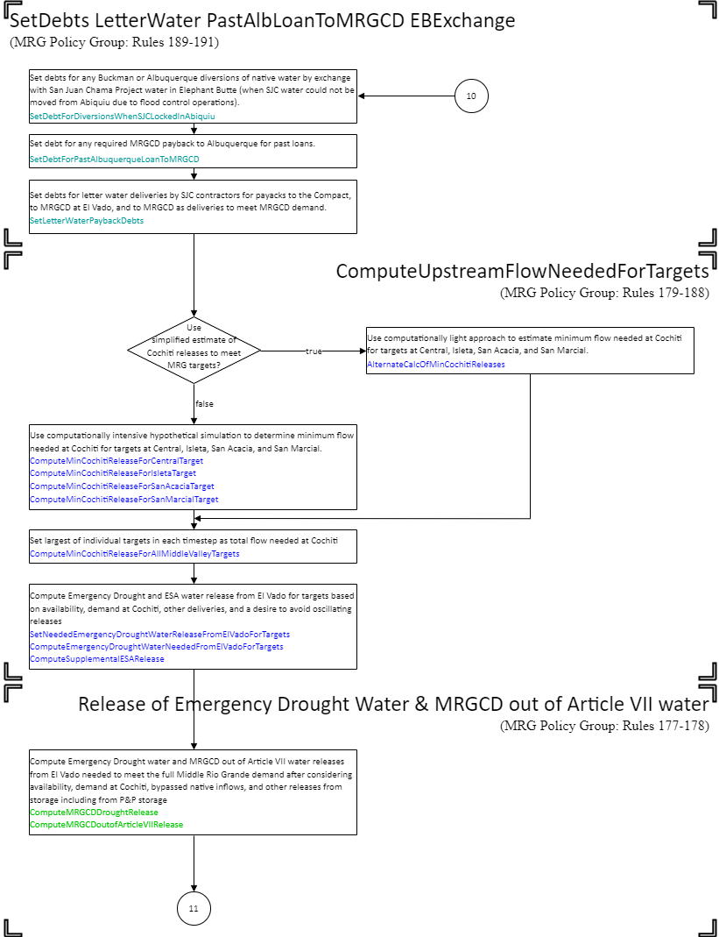

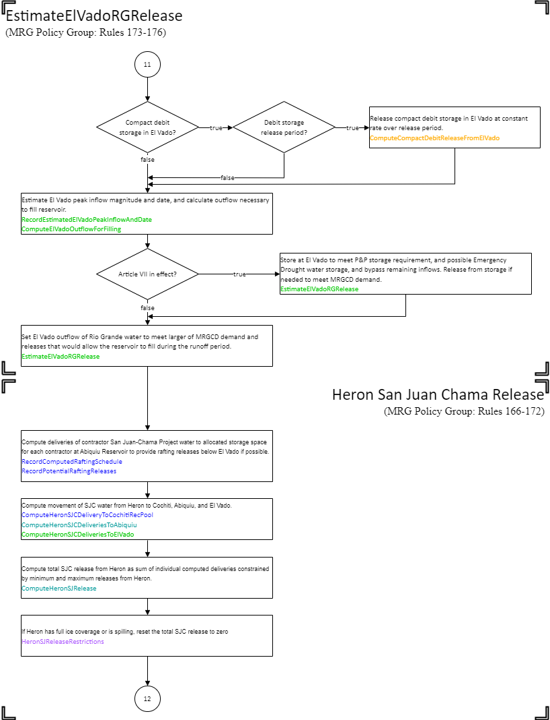

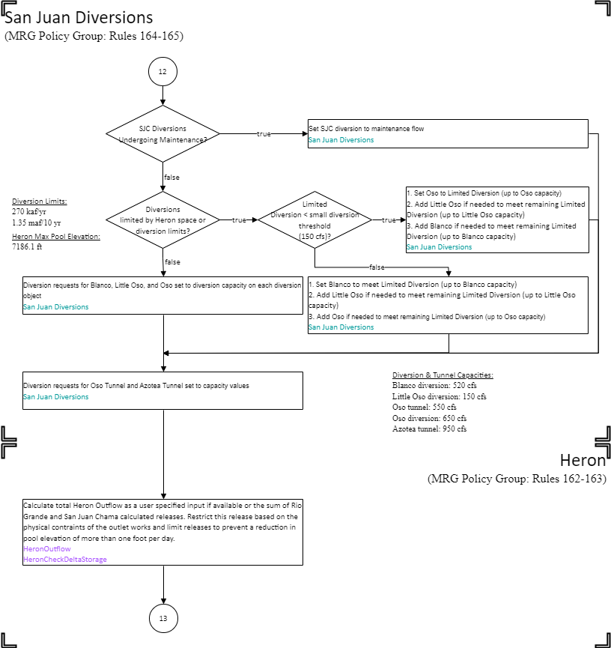

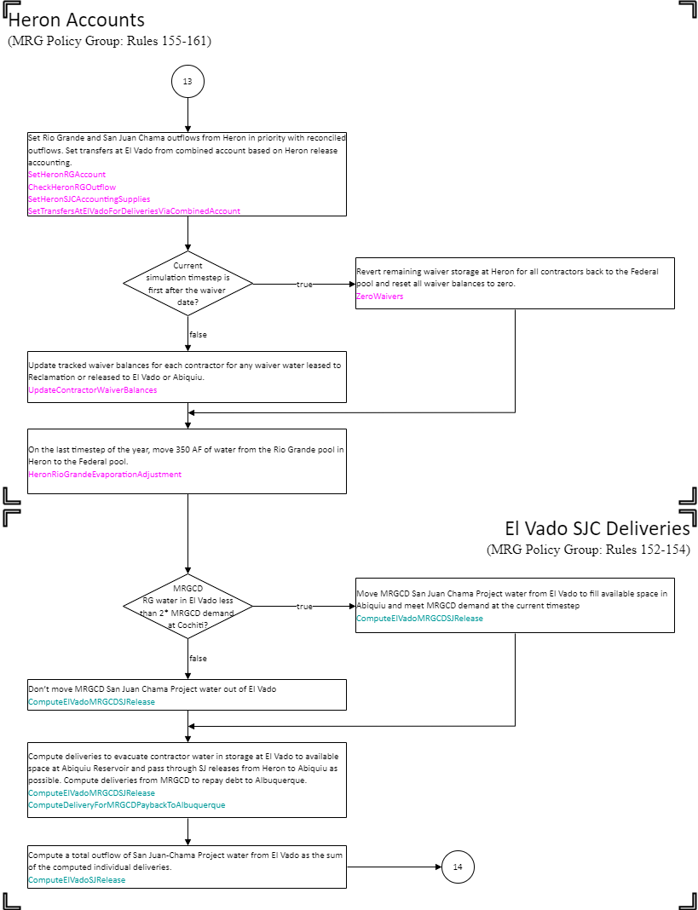

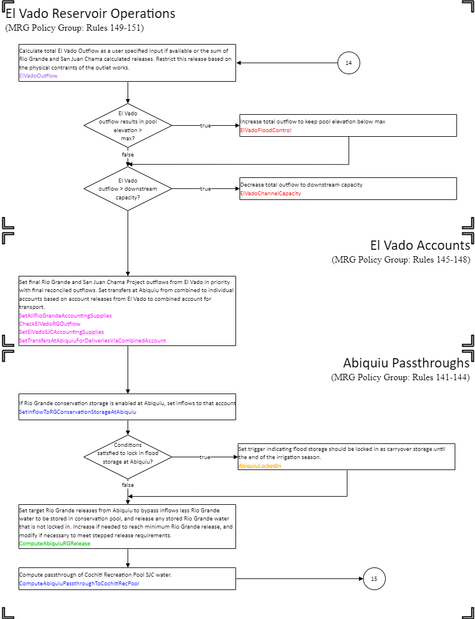

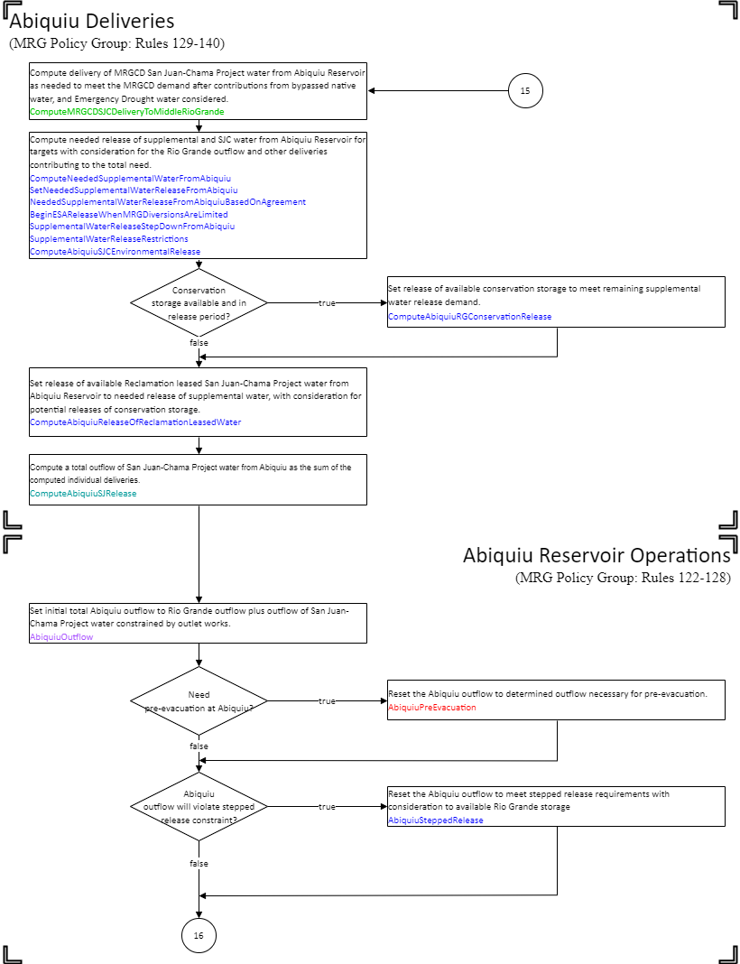

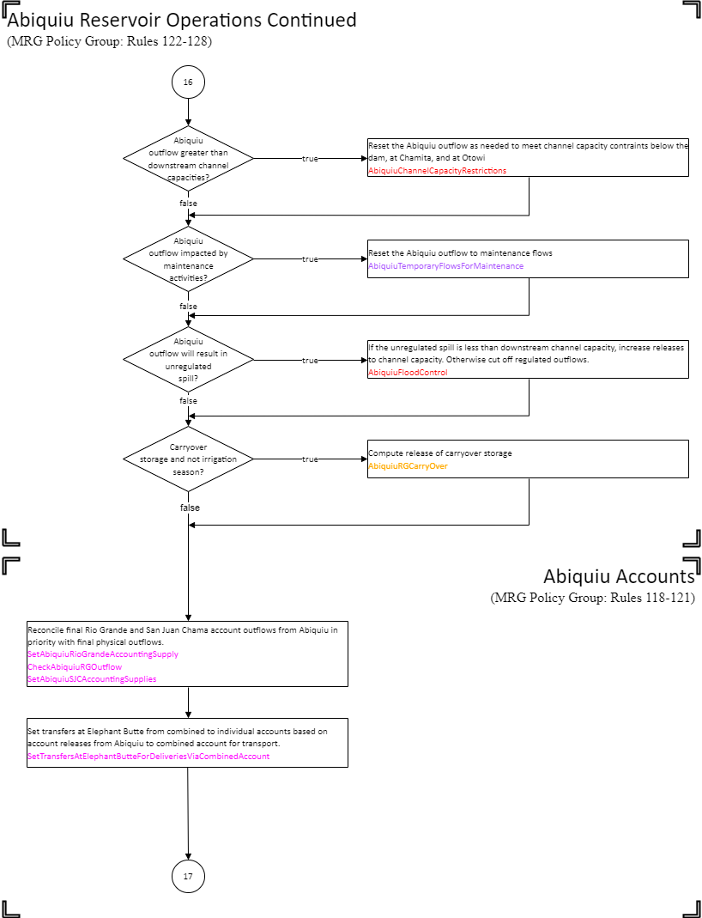

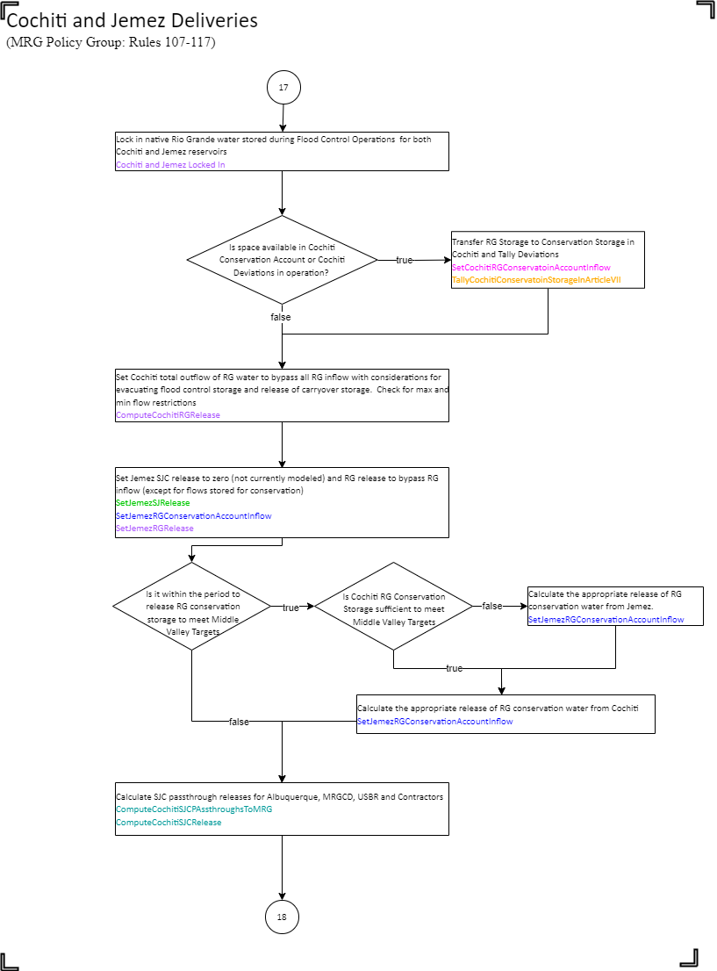

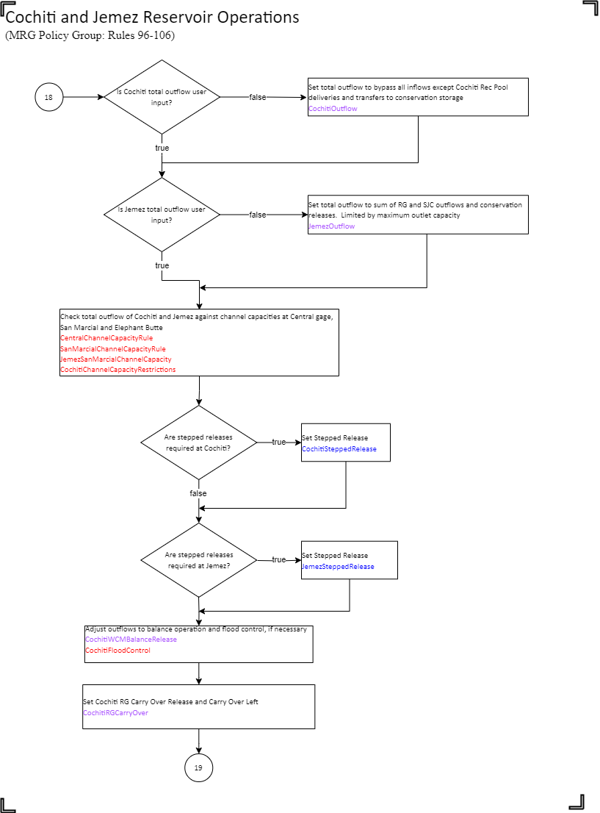

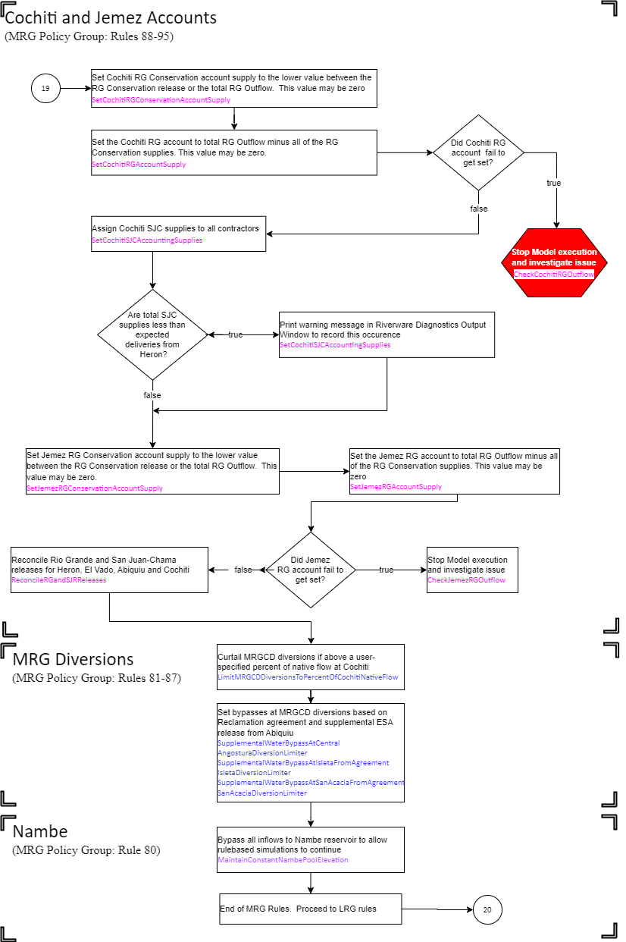

# APPENDIX D: Flowchart for Lower Rio Grande Policy

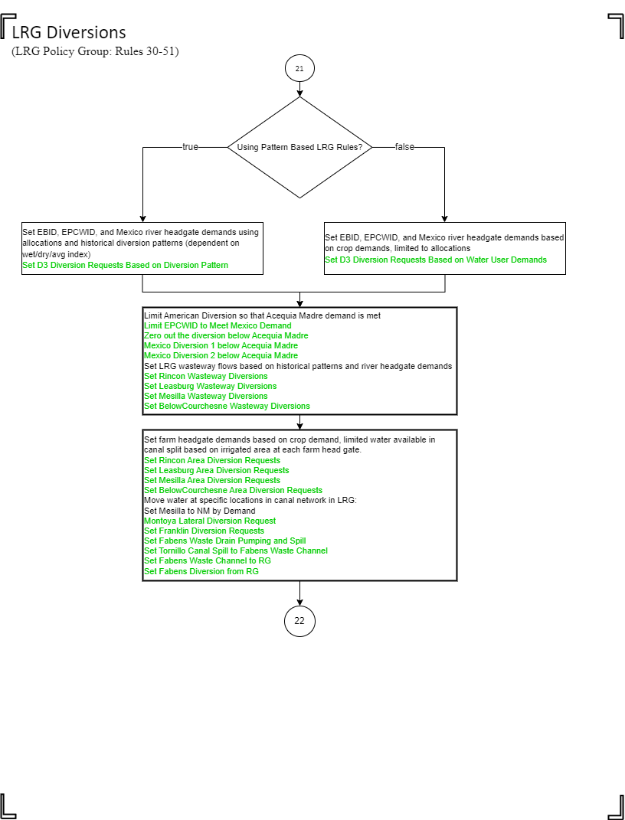

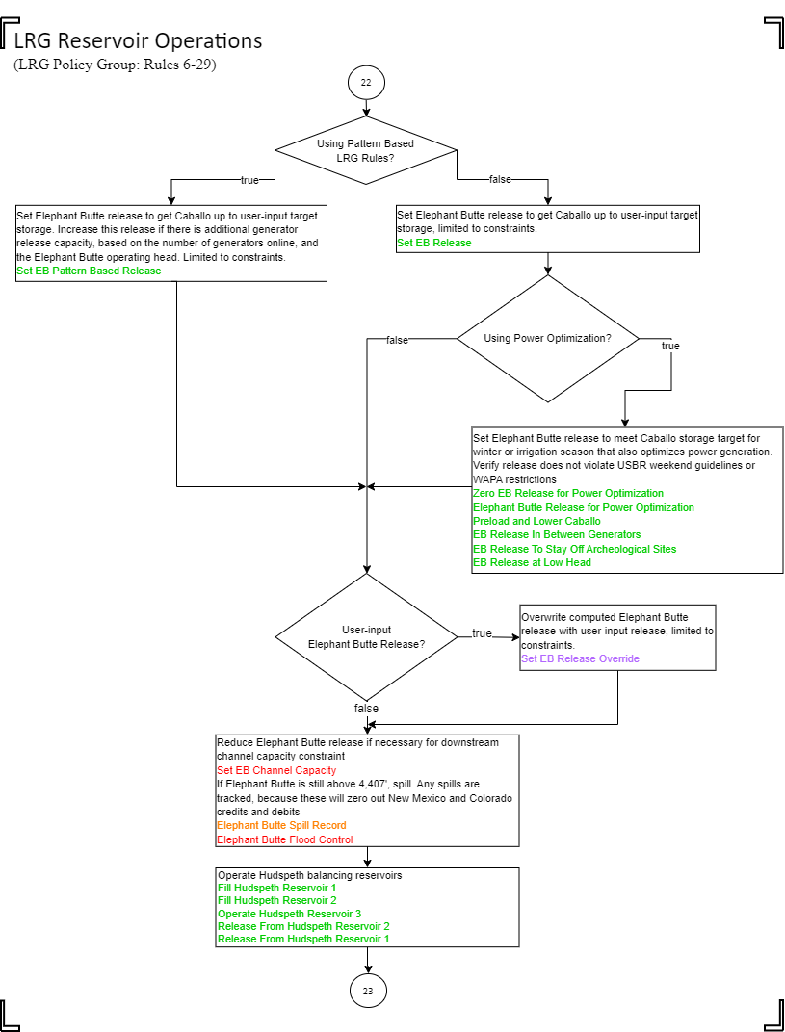

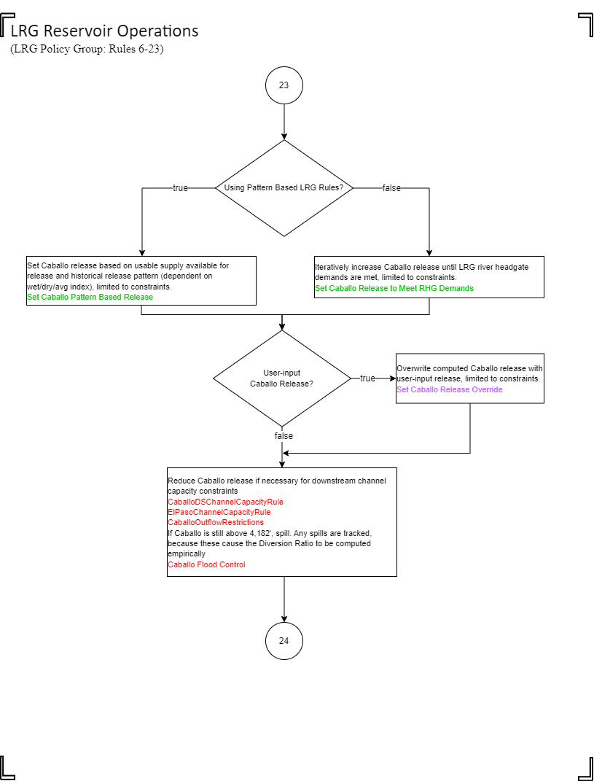

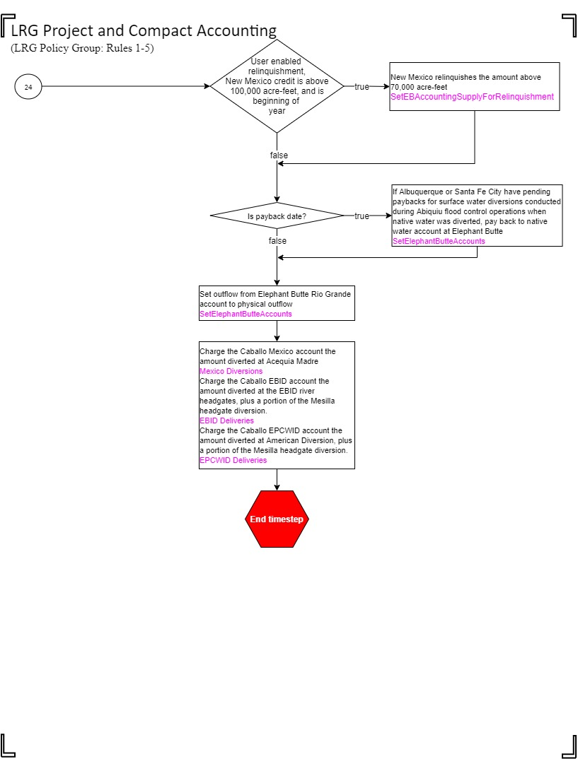

# APPENDIX E: Forecast Error & Rio Grande Compact Rules

Refer to the separate html or pdf file generated from the URGWOM model and Operations ruleset titled “URGWOM 9.3 Rules Documentation Appendix E.docx”

# APPENDIX F: Individual Colorado Rules

Refer to the separate html or pdf file generated from the URGWOM model and Operations ruleset titled “URGWOM 9.3 Rules Documentation Appendix F.docx”

# APPENDIX G: Individual Middle Rio Grande Rules

Refer to the separate html or pdf file generated from the URGWOM model and Operations ruleset titled “URGWOM 9.3 Rules Documentation Appendix G.docx”

# APPENDIX H: Individual Lower Rio Grande Rules

Refer to the separate html or pdf file generated from the URGWOM model and Operations ruleset titled “URGWOM 9.3 Rules Documentation Appendix H.docx”